9With core java knowledge we can build standalone applications

Standalone applications:

The applications which are running on single machine are called as “Standalone applications”.

e.g. Calculator, MS-word, notepad, …

If we want to develop web applications then we need to go for “Advance Java”.

What are web applications?

The applications which provide service over the web/internet are called as “Web applications”.

E.g. gmail.com, facebook.com, ineuron.com, telusko.com, ….

In java we can develop web applications using the following technologies:

1. JDBC
2. Servlet
3. JSP/Thymeleaf

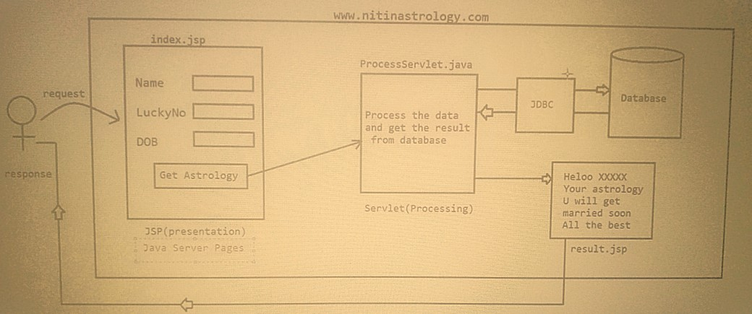

JDBC

For a Java application (Norma java class or servlet) if we want to communicate with database, then we need to go for JDBC.

JDBC -> It stands for Java Database Connectivity

e.g. To get mails information from database, To get Astrology inf from database.

The current version of jdbc is 4.X(4.2V)

Jdk s/w required => jdk8 and above

SERVLET

Whenever some processing logic is required then we need to go for servlet.

Servlet is meant for processing logic/Business logic

e.g. verify user, Communicate with the data, Process end user data

JSP (Java Server Pages)

Whenever presentation logic is required to display something to the end user then we need to go for jsp. Jsp stands for View Component

e.g. display login page

display inbox page

display error page

display result page

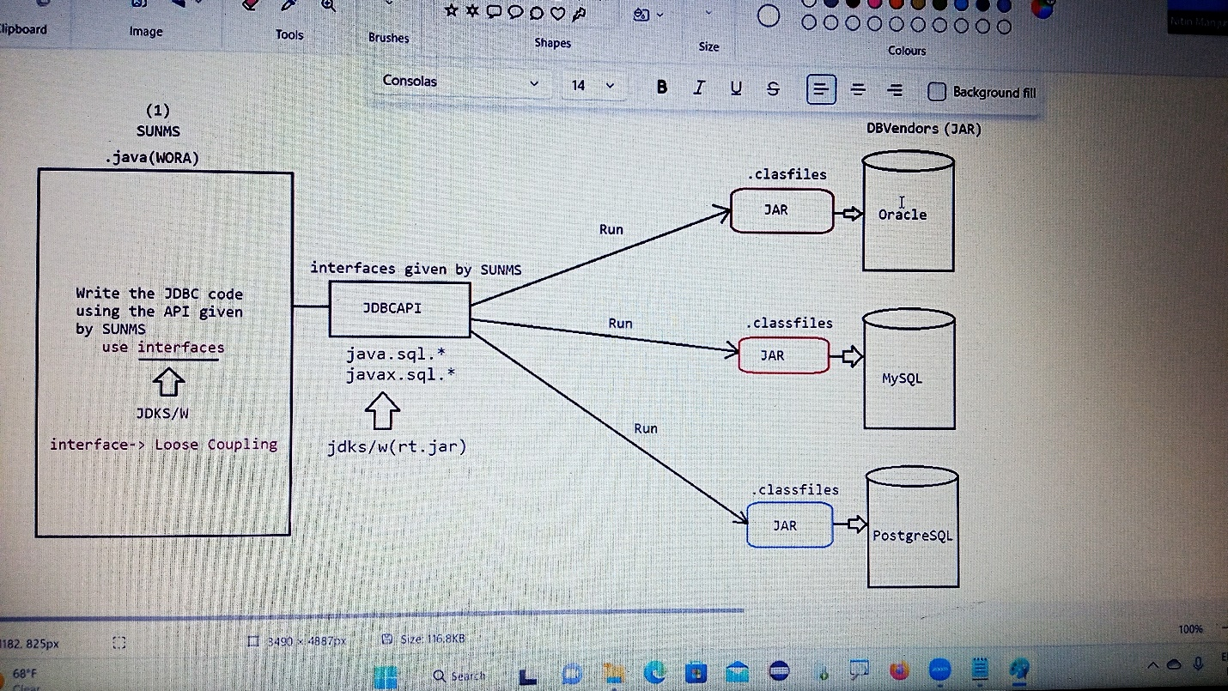

To communicate with different databases, we need the implementation classes that are in the form of jar files which are available in their website

url:mysqljarfiles

after clicking on first URL then select the platform as platform independent and click on next then click on no thanks on download.

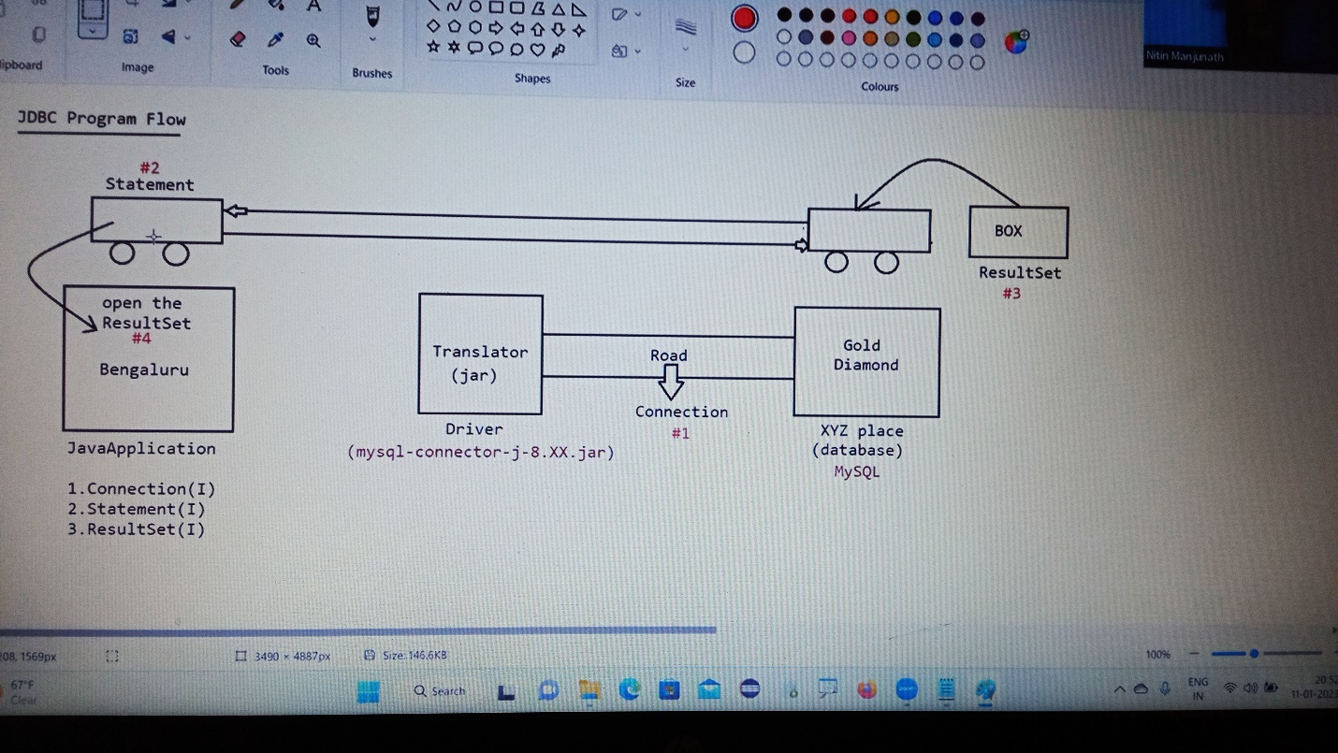

Steps given by SUMMS to communicate with Database

1)Load and register the driver

2)Establish the connection with database

3)Create Statement object and execute the query

4)Process the Resultset

5)Handle the sqlexception if it gets generated

6)Close the connection

1)Load and register the Driver

* We need to load and register the driver as per the DB requirement.
* As per the DB specification, we need to set the JRE environment with the DB environment.
* Any class of DB vendor, we say it as Driverclass, if it has implemented a interface called “Driver”.
* Mysql => The implementation class of Mysqljar is ”Driver”

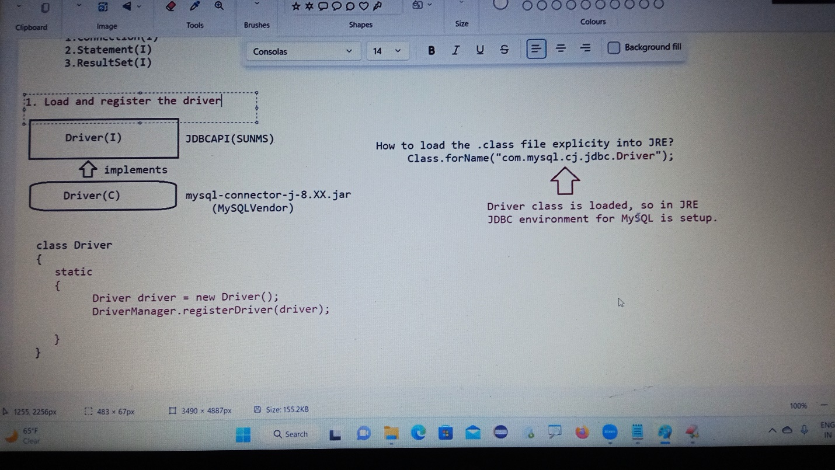

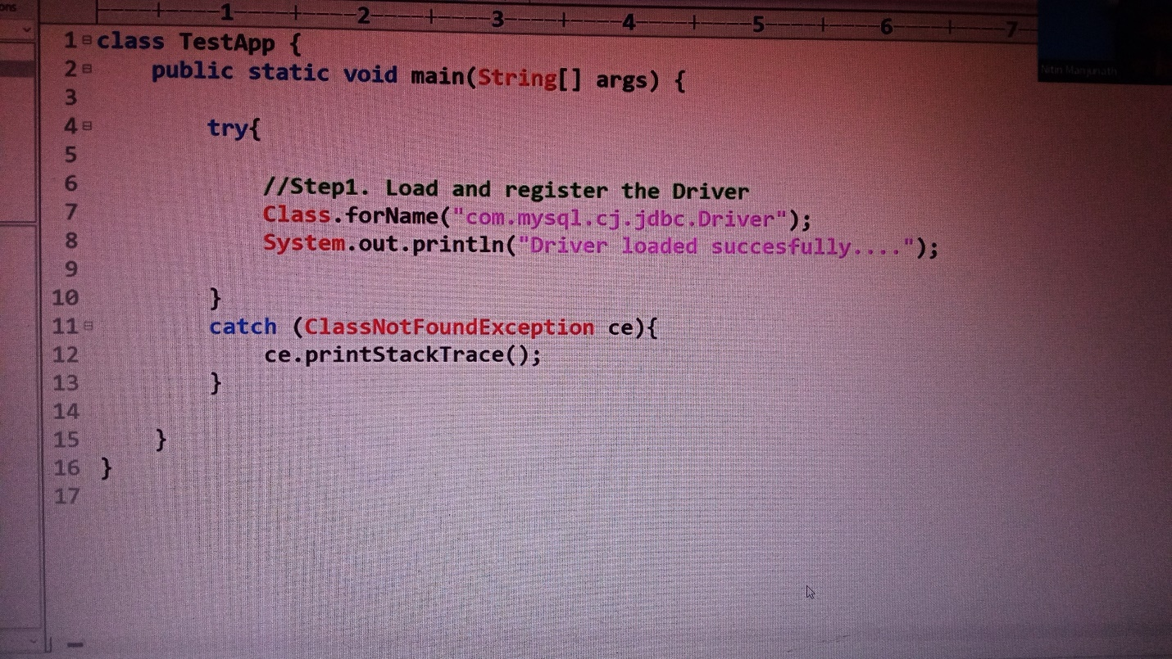

If we get error class not found exception we should set classpath for jvm to tell that it is available in this folder like

F:\jdbc>set classpath=;.;F:\jars\mysql-connector-j-9.0.0.jar

F:\jdbc>javac TestApp.java

F:\jdbc>java TestApp

Driver loaded successfully...

2) Establish a connection to database

This methods are available in java.sql.*;

public static java.sql.Connection getConnection(java.lang.String, java.util.Properties) throws java.sql.SQLException;

public static java.sql.Connection getConnection(java.lang.String, java.lang.String, java.lang.String) throws java.sql.SQLException;

public static java.sql.Connection getConnection(java.lang.String) throws java.sql.SQLException;

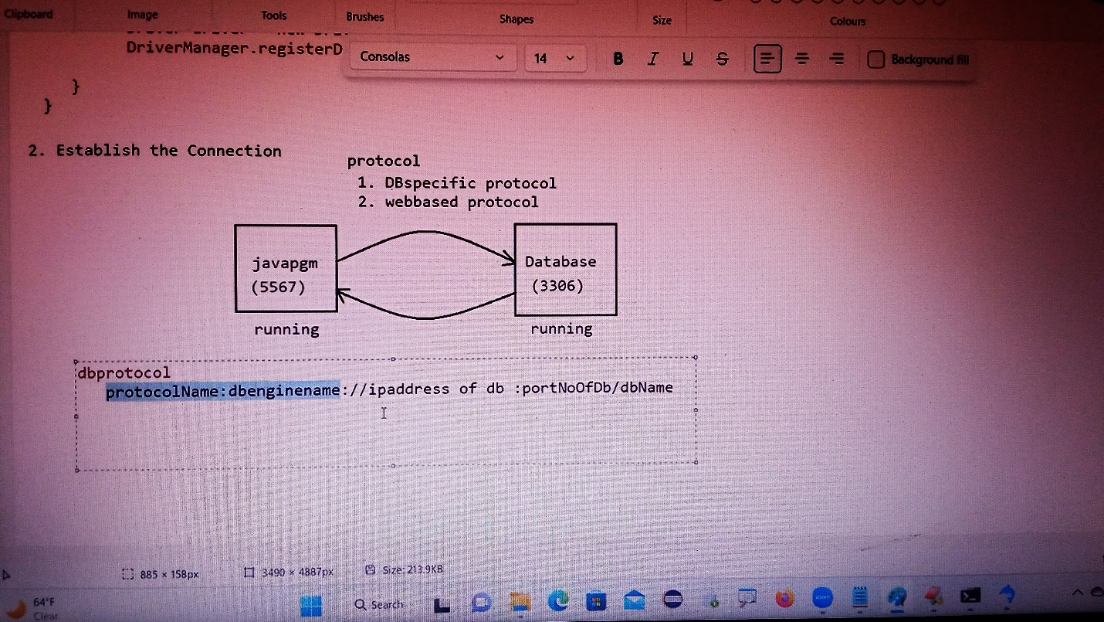

Connection connection=DriverManager.getConnection(url,username,password);

The above line would create connection object, but connection is a interface can object to interface be created?

Answer: No, for an interface instantiation is not possible

* In this line, an object to a class which implements an interface called connection is created and we hold the reference of the object with the interface name.
* This is done to promote loose coupling in java.
* The above code would also represent “abstraction”.

3)Create statement object and execute the query

Statement statement=connection.createStatement();

The above line would create Statement object, but Statement is a interface can object to interface be created?

Answer: No, for an interface instantiation is not possible

* In this line, an object to a class which implements an interface called connection is created and we hold the reference of the object with the interface name.
* This is done to promote loose coupling in java.
* The above code would also represent “abstraction”.

Resultset result=statement.executeQuery(sqlselectquery);

The above line would create resultset object, but resultset is a interface can object to interface be created?

Answer: No, for an interface instantiation is not possible

* In this line, an object to a class which implements an interface called Resultset is created and we hold the reference of the object with the interface name.
* This is done to promote loose coupling in java.
* The above code would also represent “abstraction”.

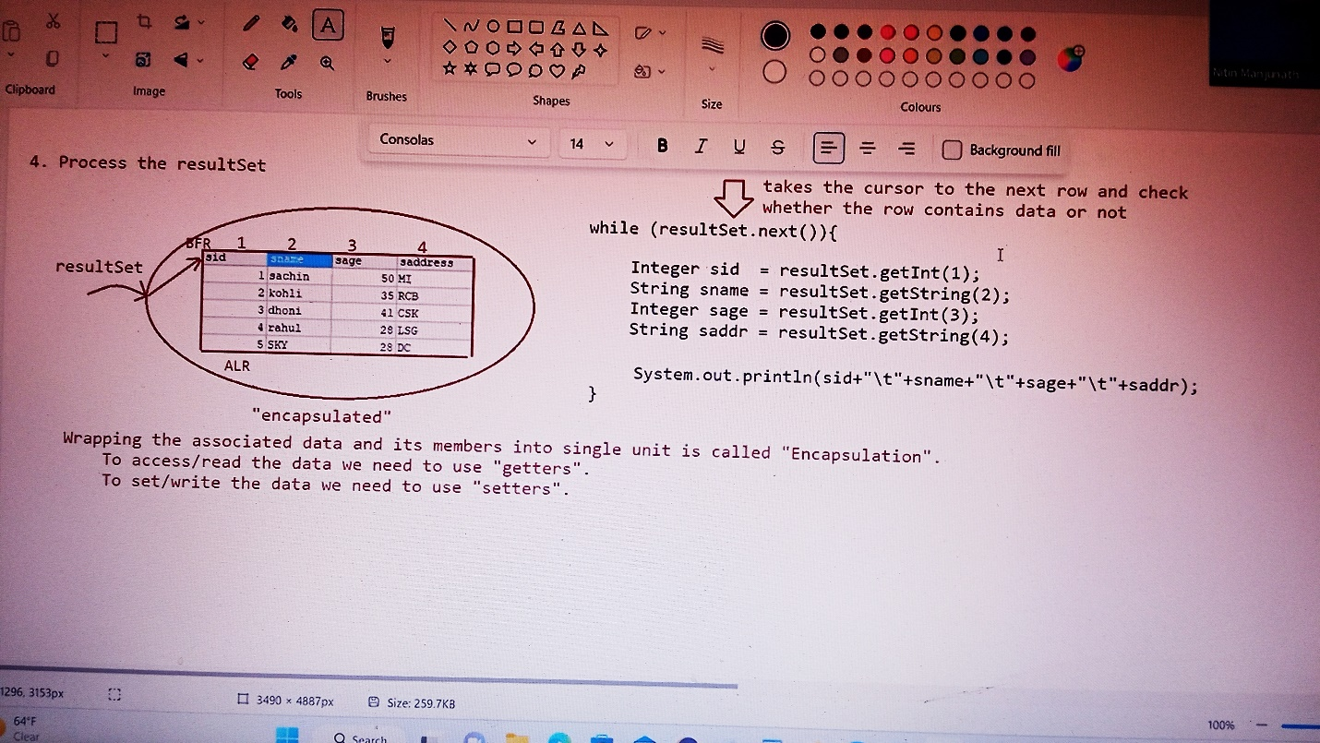

import java.sql.*;

class TestApp{

public static void main(String[] args){

Connection con=null;

Statement statement=null;

ResultSet resultset=null;

try{

//loading the driver

Class.forName("com.mysql.cj.jdbc.Driver");

System.out.println("Driver loaded successfully...");

//establishing the connection to databse

String url="jdbc:mysql://localhost:3306/Employee";

String username="root";

String password="Venkyvenkatesh8@";

con=DriverManager.getConnection(url,username,password);

System.out.println("connection established successfully");

System.out.println(con.getClass().getName());

//create a statement object

String query="select * from emp";

statement=con.createStatement();

System.out.println("The implementation of statement interface:"+statement.getClass().getName());

resultset= statement.executeQuery(query);

System.out.println("The implementation of resultset interface:"+resultset.getClass().getName());

//process the resultset

while(resultset.next()){

Integer Eid=resultset.getInt(1);

String Ename=resultset.getString(2);

String job=resultset.getString(3);

Integer mgr=resultset.getInt(4);

Double sal=resultset.getDouble(6);

Integer comm=resultset.getInt(7);

Integer deptno=resultset.getInt(8);

System.out.println(+Eid+"\t"+Ename+"\t"+job+"\t"+mgr+"\t"+sal+"\t"+comm+"\t"+deptno);

}

}

catch(ClassNotFoundException ce){

ce.printStackTrace();

}

catch(SQLException se){

se.printStackTrace();

}

catch(Exception e){

e.printStackTrace();

}

finally{

if(con!=null){

try{

con.close();

System.out.println("connection successfully closed");

}catch(SQLException sq){

sq.printStackTrace();

}

}

}

}

}

How to setup mysql jar files in eclipse?

1. Right click on project name
2. Then click on properties or click on Build path

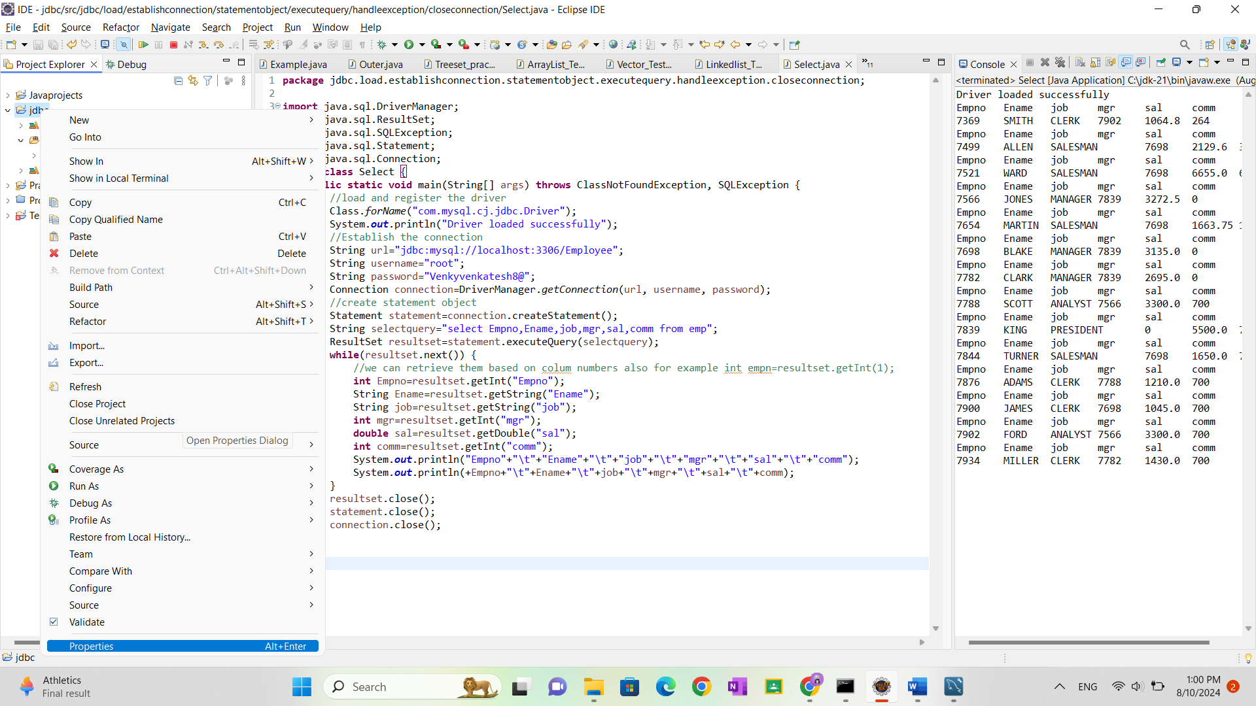

1. Then add a library by clicking and Add library

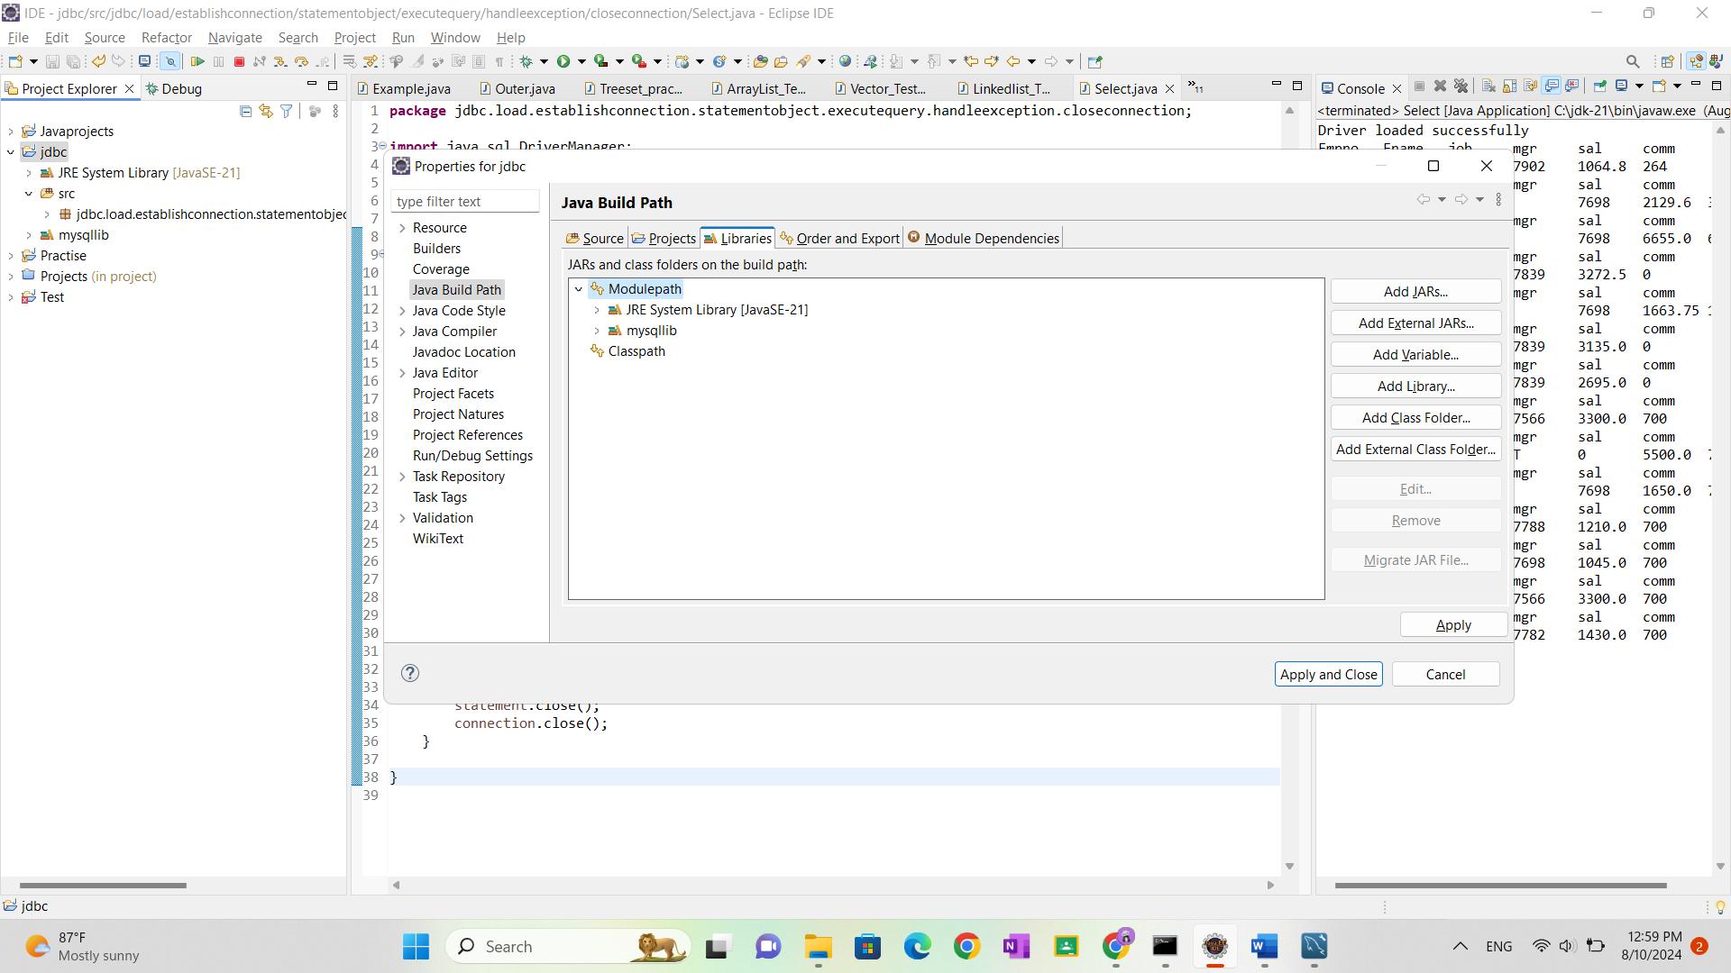

1. Then click on userlibrary

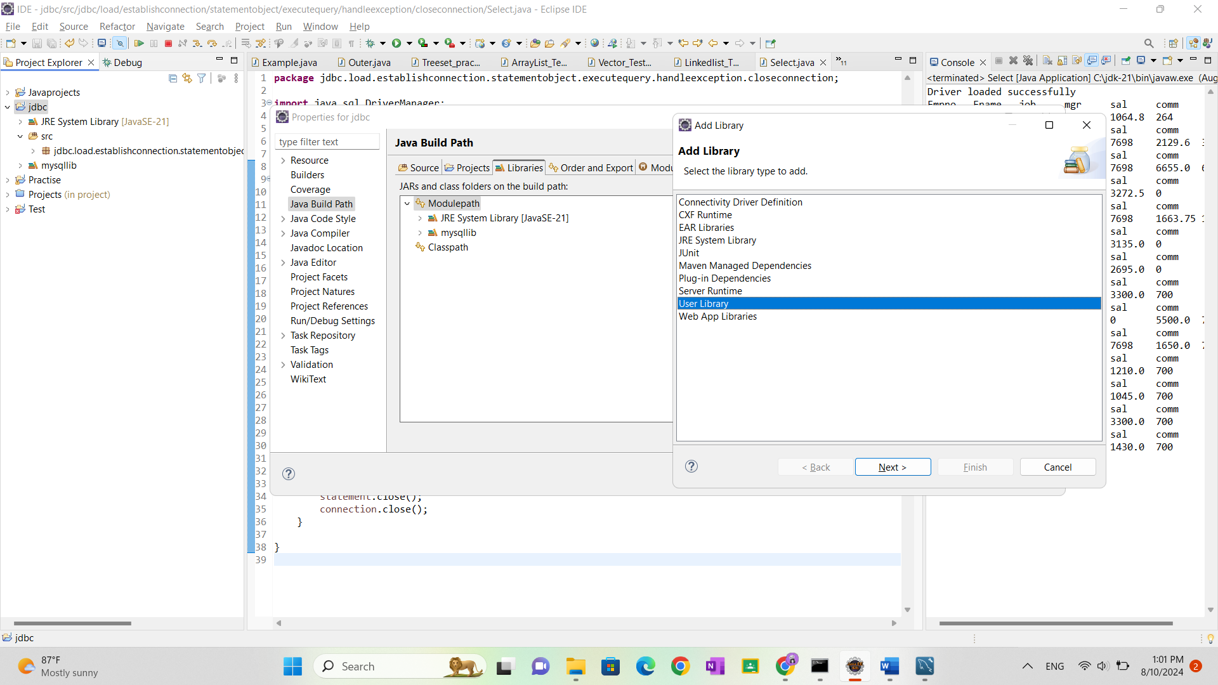

1. Then it will show list of user libraries then click on user libraries

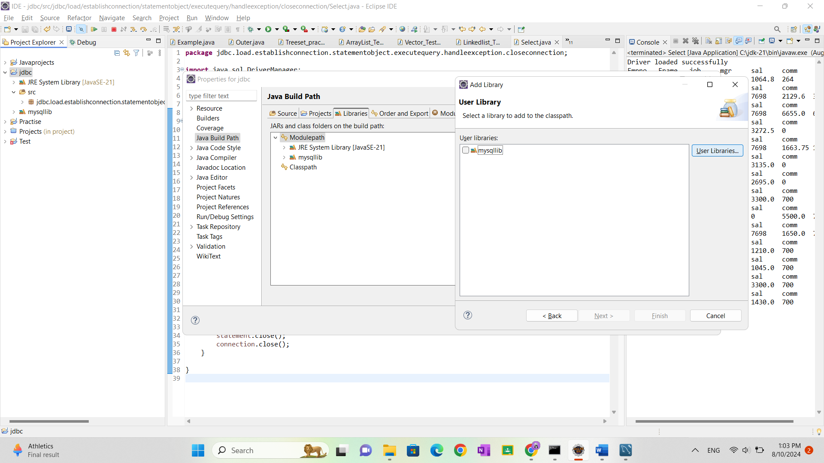

1. Then click on new and enter library name

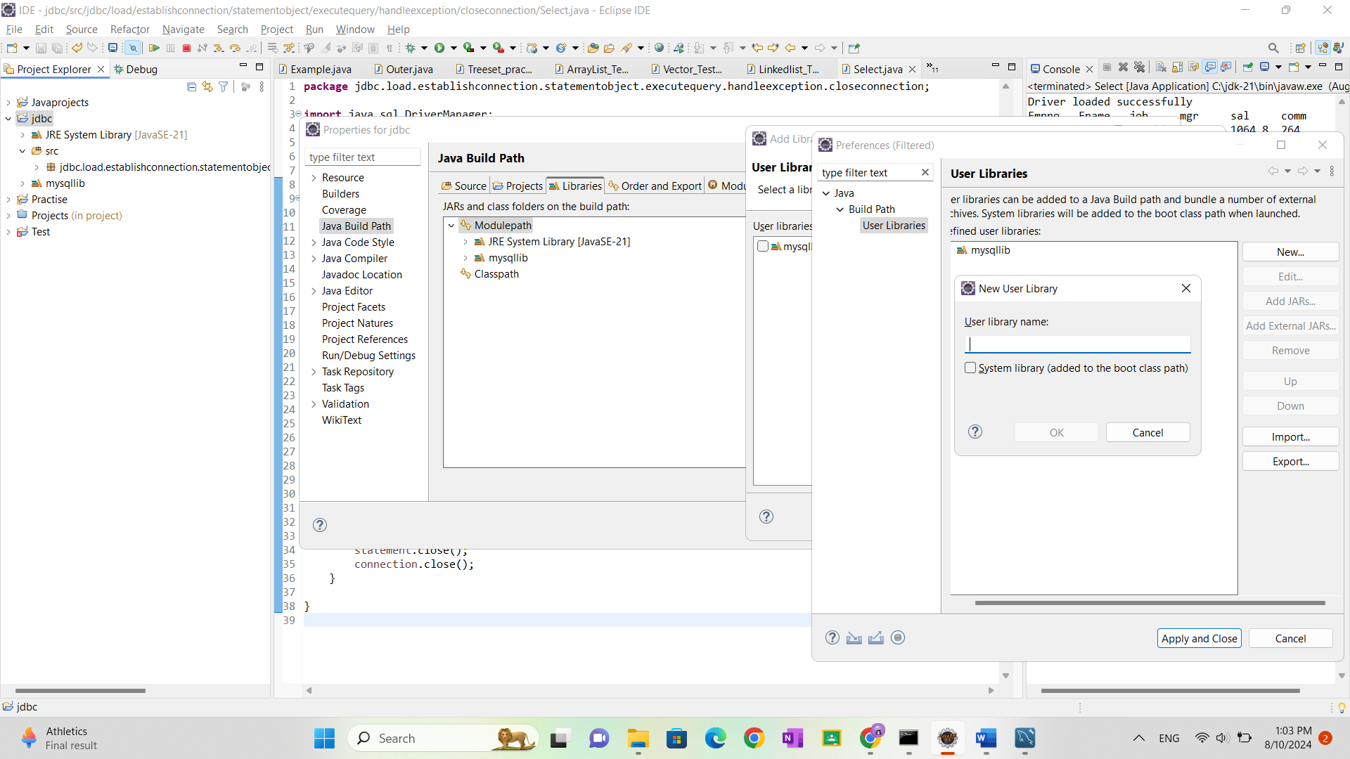

1. After entering library name click on ok and then click on add external jars and select the path of jar file click on ok.

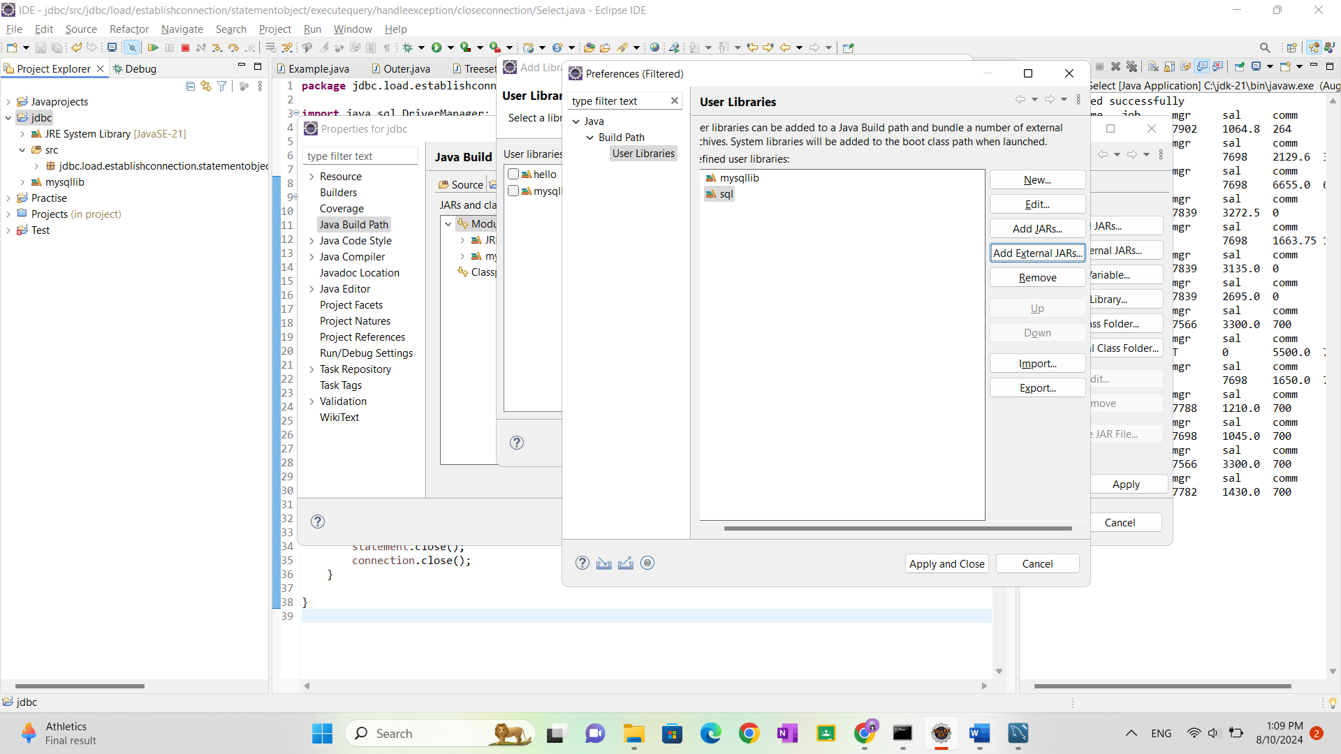

Day-2

From JDBC4.X onwards , there is a facility of “autoloading”.

Q>What is autoloading in JDBC?

Loading and register the driver is done automatically, based on the URL

Supplied by the user.

Behind the scenes

* Check the URL
* Based on the URL supplied, go to class path environmental
* Open the relevant jar
* Go to META-INF/services folder
* Open java.sql.Driver file
* Read the file and load the class supplied in the file

Note: Using result set object , we can retrieve the records based on column name.

If java program and database engine is running in the same program with default port no for database then URL can be of the following type.

String URL=” jdbc: mysql:///Employee”;

Note: According to DBA specification, all SQL commands are categorized into following types

1)DDL(Data Definition Language)

E.g.: create table, alter table, drop table…. Etc

2)DML(Data Manipulation Language)

E.g.: insert, update, delete…etc.

3)DQL(Data Query Language)

E.g.: select

4)DCL(Data Control Langauge)

E.g.: Alter password, grant access….

5)DA command(Data Administration Commands)

E.g.: start audit, stop audit

6)TCL(Transition Control Language){

E.g.: commit, rollback, savepoint….

According to java developer point of view all SQL operation are classified into two types:

1)Select operation (DQL)

2)Non select operation (DML.DDL….)

Through statement object we need to execute the query and to execute the query we need to make a call to a method as shown below:

1)executeQuery()

2)executeupdate()

3)execute ()

1)executeQuery()

This method is used only if we perform select operation.

Because of this method execution, we will get a group records which are represented as “Resultset” object.

Public Resultset exdcuteQuery(String sql)throws SQLException;

E.g. Resultset resultset=statement.executeQuery(“select eid,ename,salary,depno from emp);

2)executeupdate()

This method is used for Non-select operations(insert|update|delete)

Because of this method execution, we won’t get group of records, we will get a numeric value which represents the numbers of rows affected. So return type of this method is “int”.

Public int executeupdate(String sql)throws SQL Exception;

E.g. int rowsaffected=statement.executeupdate(“delete from emp where deptno=10");

System.out.println(“No of rows effected:”+rowsaffected);

3)execute()

We can use this method for both select and non select operation .

If we don’t know the type of query at the beginning and if it is available at dynamically at runtime then we need to use this method for execution.

Public boolean execute(String sql)throws SQL Exception;

E.g. boolean value=statement.execute(dynamic query);

if(value==true){

Resultset resultset=statement.getResultset();

//process the resultset

}

else{

int rowcount=statement.getupdateCount();

System.out.println(“number of rows effected:”+count);

}

Formatting SQL Queries using dynamic input

1st approach:

Sname=sc.next();

Sage=sc.Int();

Saddress=sc.next();

String sqlinsertquery=”insert into student(sname,sage,saddress)values(‘“+sname+”’,”+sage+”,”’”+saddress”’)”;

2nd approach

Sname=sc.next();

Sage=sc.nextInt();

Saddress=sc.next();

Sname=” ‘ “+sname+ “ ‘ “;

Saddress=” ‘ “+saddress+” ‘ “;

String sqlinsertquery=”insert into student(sname,sage,saddress)value(“+sname+”,”+sage+”,”+saddress+”)”;

3rd approach:

The above two approaches are not recommend, to do formatting we prefer using string class format() as shown below.

Public static String format(String format,Object…args)

Sname=sc.next();

Sage=sc.Int();

Saddress=sc.next();

String insertquery=String.format(“insert into student(sname,sage,saddress)values(‘%s’,%d,’%s’)”,sname,sage,saddress);

Note:

While writing JDBC code, the following steps are common

1. Establishing the connection
2. Closing the resources

What would vary in every code is

1. Query will be different
2. If it is select process the Result set Object
3. If it is non-select, process the integer value

Package jdbc.util;

Class jdbcUtil{

private jdbcUtil(){

}

Static{

try{

Class.forName(“com.mysql.cj.jdbc.Driver”);

System.out.println(“Driver is loaded successfully”);

}catch(ClassNotFoundException ce){

Ce.printStackTrace();

}

}

Public static Connection getjdbcConnection()throws SQLException{

FileInputStream fis=new FileInputStream(“path of the properties file”);

Properties properties=new Properties();

properties.load(fis);

String url=”jdbc:mysql:///Employee”;

String username=”root”:

String password=”Venkyvenkatesh8@”;

Connection connection=DriverManager.getConnection(properties.getProperty(url),properties.getProperty(username),properties.getProperty(password));

return connection;

}

Public static void closeresources(Connection connection,Statement statement,Resultset resultset){

If(connection!=null){

connection.close();

}

If(statement!=null){

statement.close();

}

If(resultset!=null){

resultset.close();

}

Note:

In the above code , the url pattern ,username,password is hardcoded

These values would vary from user to user

To set these values, we use properties file approach as shown below

You can create properties file like this

url=jdbc:mysql:///Employee

username=root

password=Venkyvenkatesh8@

Why java developers classified the sql operation into two categories

ANS) Because to execute the query through statement object we don’t have more methods so they classified it as two categories

If you want to communicate with the oracle database this is the url

**url=jdbc:oracle:thin:@localhost:1521:XE**

username=system, password=Venkyvenkatesh8@

The life cycle of Query Execution

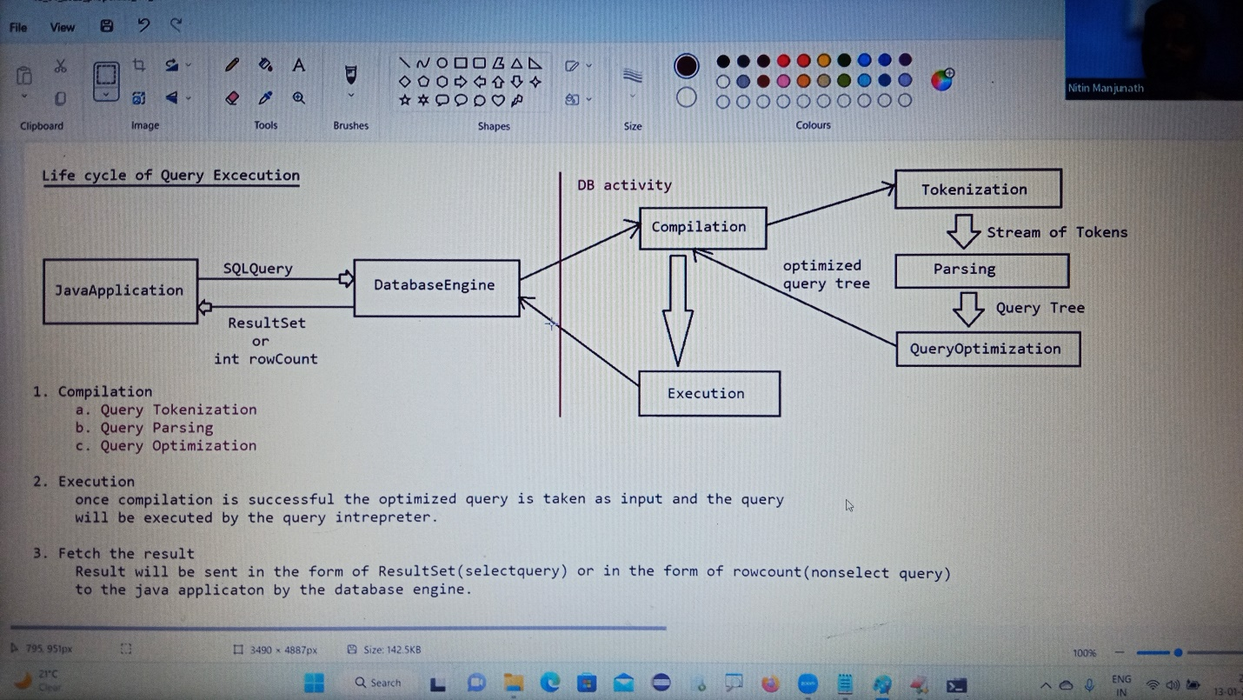

Need of Prepared Statement

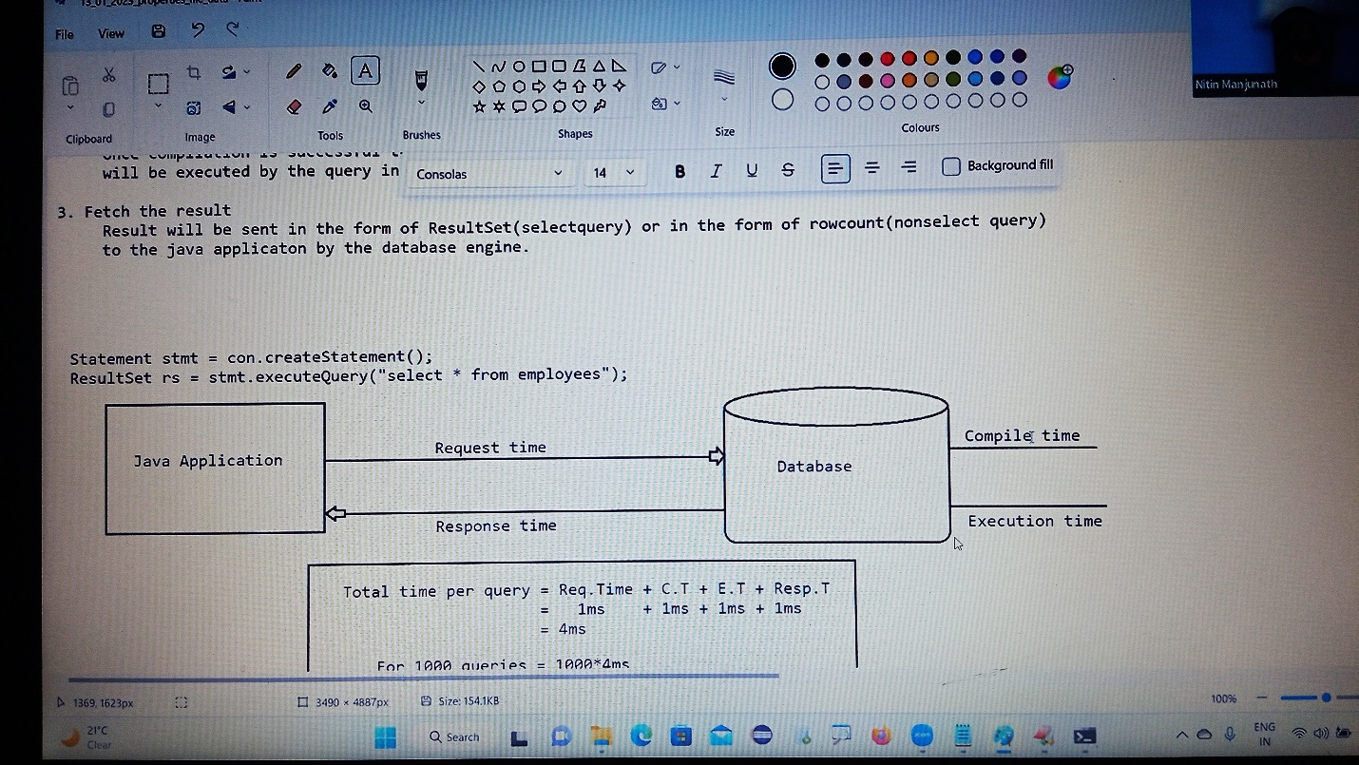

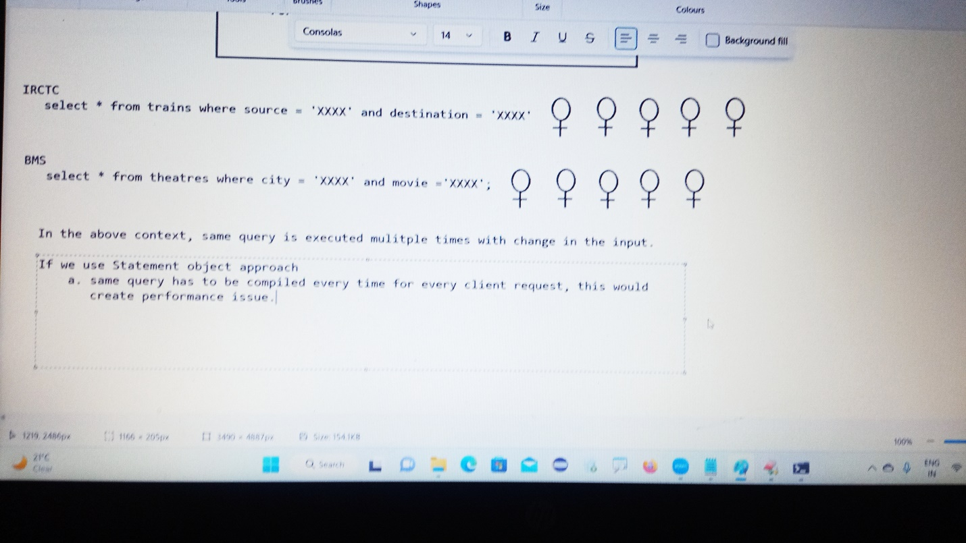

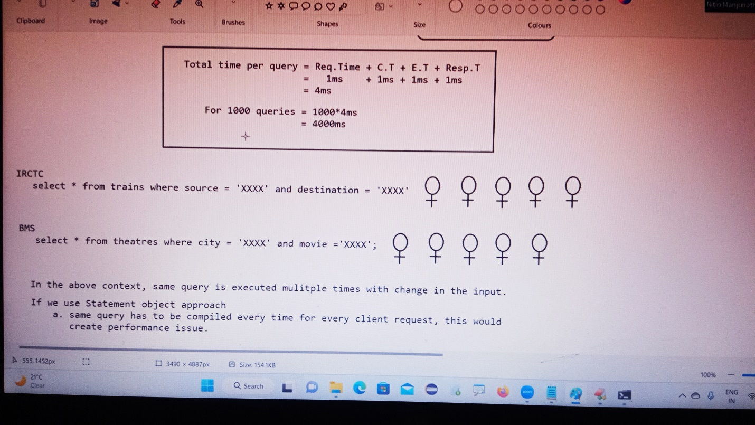

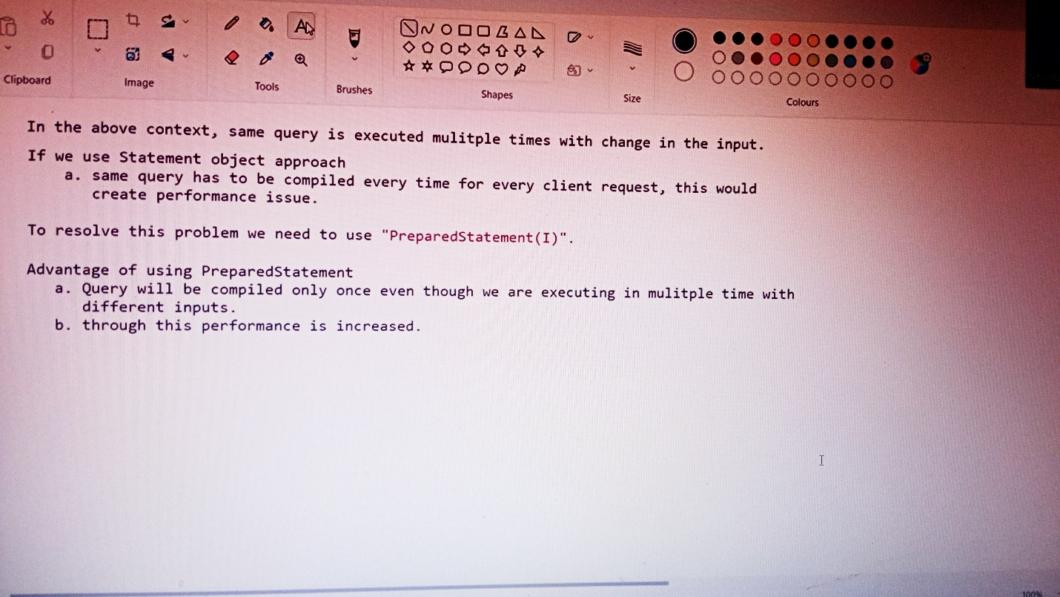

Preparedstatement preparestatement (String query) throws SQLException;

Preparedstatement preparestatement=con. preparestatement(sqlquery);

1)At this line query will be sent to database engine

2)Database engine will compile the query and stores in the database

3)The precompiled code query will be sent to the java application in the form of preparedstatement object.

While using Preparedstatement the query would be as shown below:

String sqlquery=”insert into emp(empno,ename,sal,job,depno)values(?,?,?,?)”;

Preparedstatement preparestatement=connection.prepareStatement(sqlquery);

Preparestatement.setInt(1,200);

Preparestatement.setString(2,”Venkatesh”);

Preparestatement.setDouble(3,2000);

Preparestatement.setString(4,”Developer”);

Preparestatement.setInt(5,20);

Int rowcount=Preparestsatement.executeUpdate();

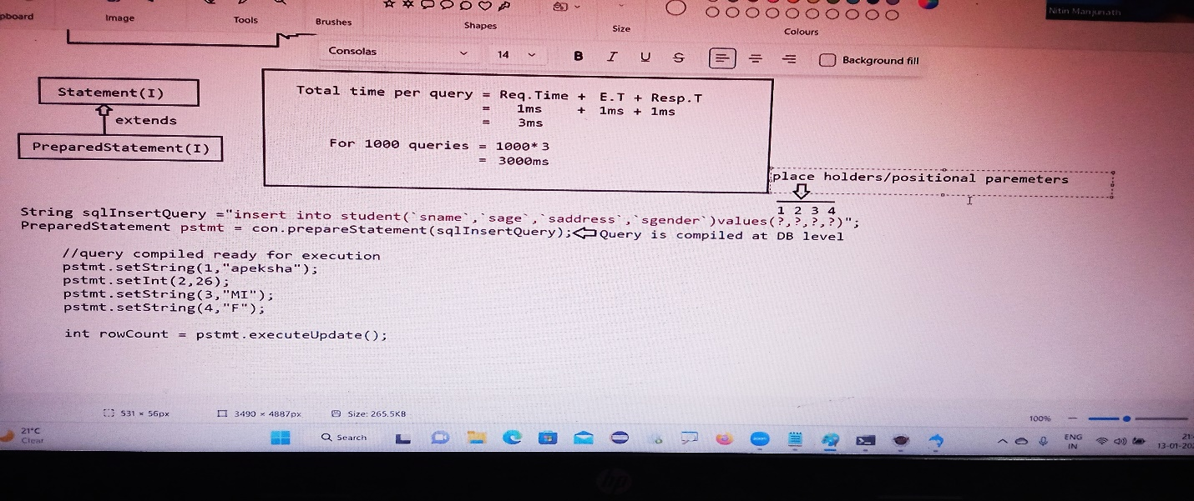

Statement object represents only one query and it can be executed only once with no change in inputs.

Advantages of PreparedStatement:

1)Performance is very high compared to statement approach because query will be compiled only once.

2)Since we don’t send the query multiple times between java application and database traffic will be reduced

3)inputs to the query need not be supplied at the beginning dynamically we can supply the inputs.

4)inputs to the query can be supplied just like java style, no need to perform formatting as per the DB specification

5)Best suitable for inserting Date values.

6)Best suitable for insertion of BLOB’s and CLOB’s(image and pdf files).

7)It prevents SQLInjection Attack.

Limitations of PreparedStatement:

Statement stmt=connection.createStatement();

Stmt.executeUpdate(“insert into student values()…”);

Stmt.executeQuery(“select * from student”);

Stmt.executeUpdate(“delete from student where…”);

One statement object can be used to execute multiple query but with no change in inputs.

PreparedStatement pstmt=connection.prepareStatement(“select * from emp”);

Pstmt.executeQuery();

One preparedstatement object is restricted to only one query can be executed multiple times with change in input

Which of the following represent valid statement?

1)delete from employee where enmae=? (valid)

2)delete from employee ? ename= ? (invalid)

3)delete from ? where ename=? (invalid)

4)delete ? employees where ename=? (invalid)

Note: we can use ? only in the place of input values and we cannot use in the place of sql keywords, tablenames and column names.

Static query vs Dynamic query:

The sql query without positional parameter(>) is called static query.

Eg: delete from employee where ename=’sachin’;

The sql query with positional parameter(?) is called dynamic query

Eg: delete from emp where ename=?

Select eid,ename,sal from emp where sal>?

Simple statement object can be used for static queries, where as preparedstatment object can be used for static queries and dynamic queries also.

Handling Date values for Database Operations

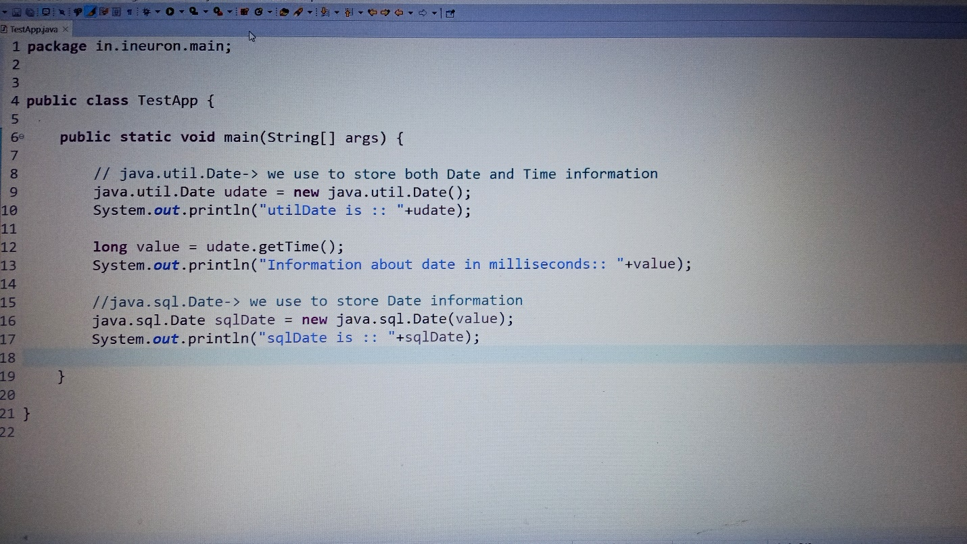

=>some times as part of programming requirement, we have to insert and retrieve date like DOB,DOJ,DOM,DOP…wrt database.

=>It is not recommended to maintain date values in the form of string because comparisons will become difficult.

In java we have two Date classes

1)java.util.Date

2)java.sql.Date

=>java.sql.Date is the child class of java.util,Date

=>java.sql.Date is specillay designed class for handling date values wrt databse

Otherthan databse operations, if we want to represent Date in our java program then we should go for java.util.Date

=>java.util.Date can represent both date and time where as java.sql.Date represents only Date but not time.

Class Test{

Public static void main(String[] args){

Java.util.Date udate=new java.util.Date();

System.out.println(“util Date:”+udate);

Long l=udate.getTime();

Java.sql.Date sdate=new java.sql.Date(l);

}

}

Util Date:Mon Mar 20 19:07:29 IST 2017

Sql Date:2017-03-20

Differences between java.tui.Date and java.Sql.Date

Java.util.Date

1)It is general utility class to handle dates in our java program

2)It represents both Date and Time

Java.sql.Date

1)It is specially designed class to handle dates with respective to Database operations.

2)It represents only date but not time

Note: In sql package time class is available to represent time values and timestamp class is available to represent both Date and Time.

=>If we use simple statement object to insert date values then we should provide date value in the database supported format

=>If we use preparedstatement object then we are not required to worry about database support format

Just we have to call

Preparedstatement.setDate(java.sql.Date);

This method internally converts date value into the database supported format.

Hence it is highly recommended to use preparedstatement to insert date values into database.

Steps to insert Date value into Database:

=>DB : create table users(name varchar2(10,dob date);

1) read Date from the end user(in String form)

System.out.println(“Enter DOP(dd-mm-yyyy):”);

String dop=sc.nxext();

2)convert date from string form to java.util.Date form by using SimpleDateFormat object.

Simpledateformat sdf=new simpledateformat(“dd-mm-yyy”);

Java.util.Date udate=sdf.parse(dop);

3)convert date from java.util.Date to java.sql.Date

Long l=udate.getTime();

Java.sql.Date sdate=nnew java.sql.Date(l);

4)set sdate to query

Preparedstatement.setDate(2,sdate);

5)int rowAffected=pst.executedUpdate();//Execute the query.

***Note: If end user provides Date in the form of “yyyy-MM-dd” then we can convert directly that string into java.sql.Date form as follows…

String s=”1980-05-27”;

Java.sql.Date sdate=java.sql.Date.valueof(s);

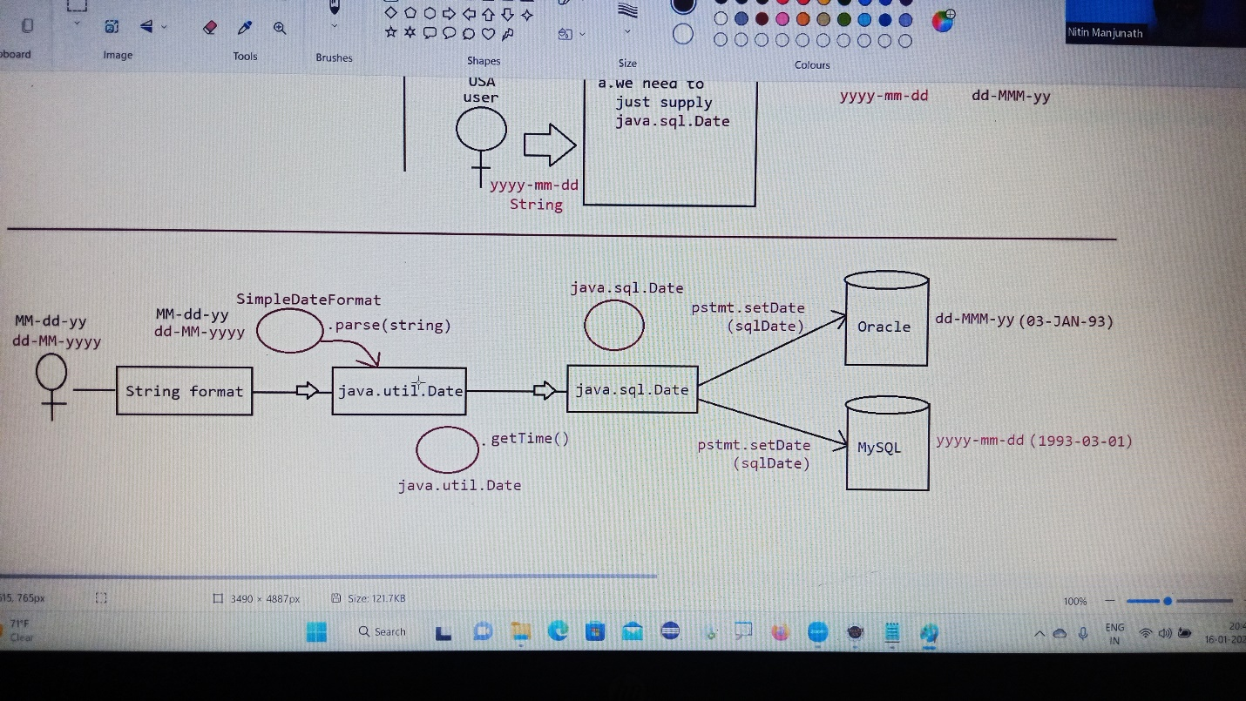

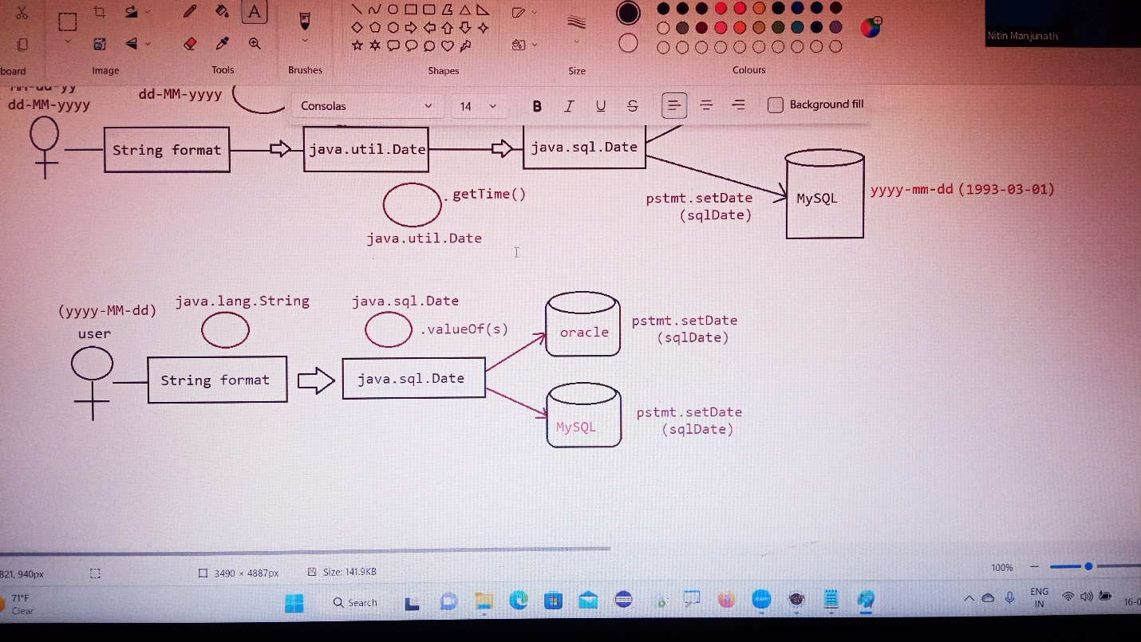

If you want to work with the oracle database this is the url first setup the oracle connector

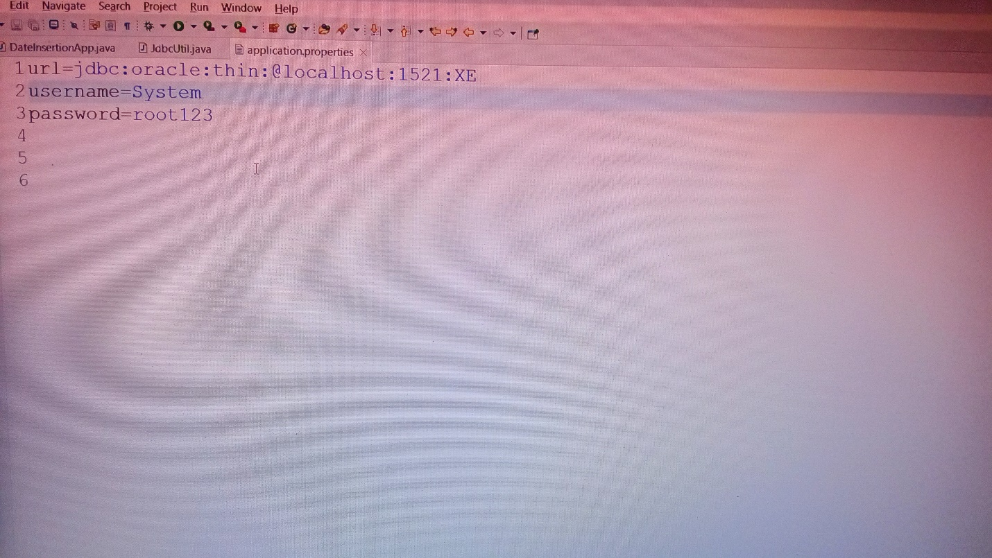

Retrieval of Date Object from database:

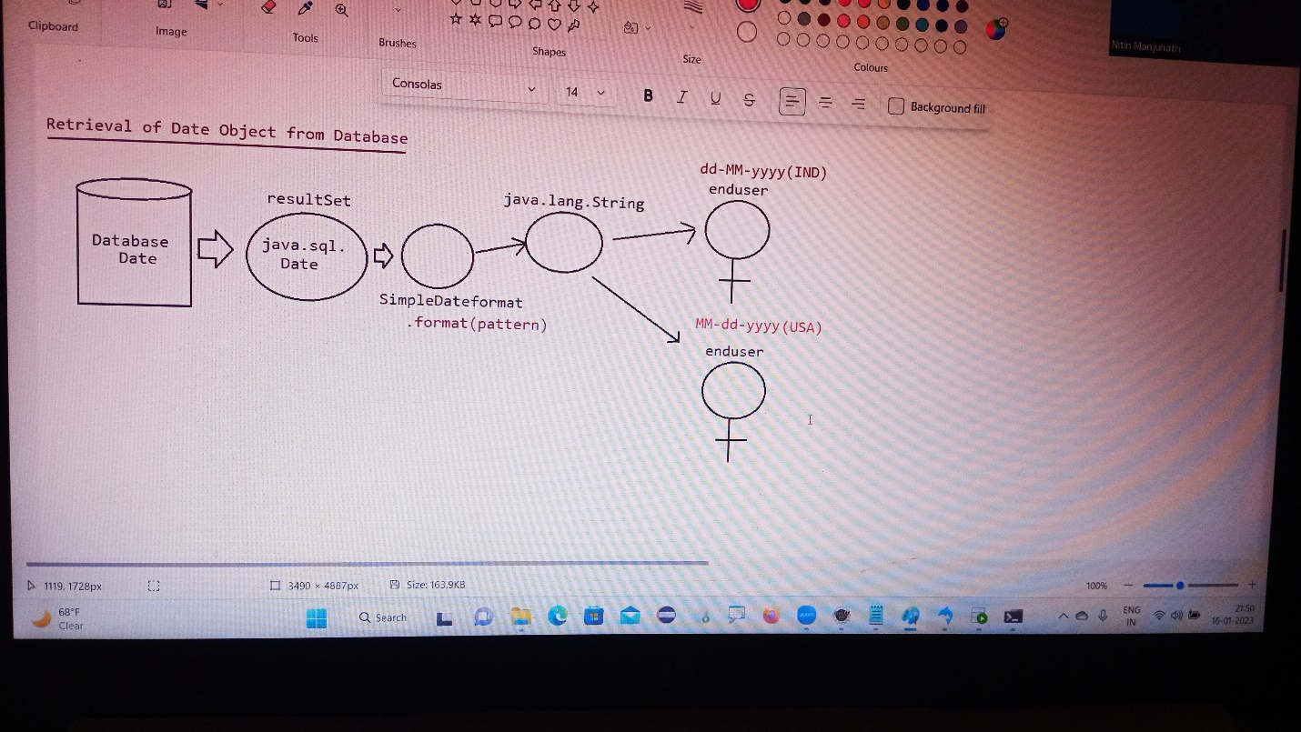

Application development process:

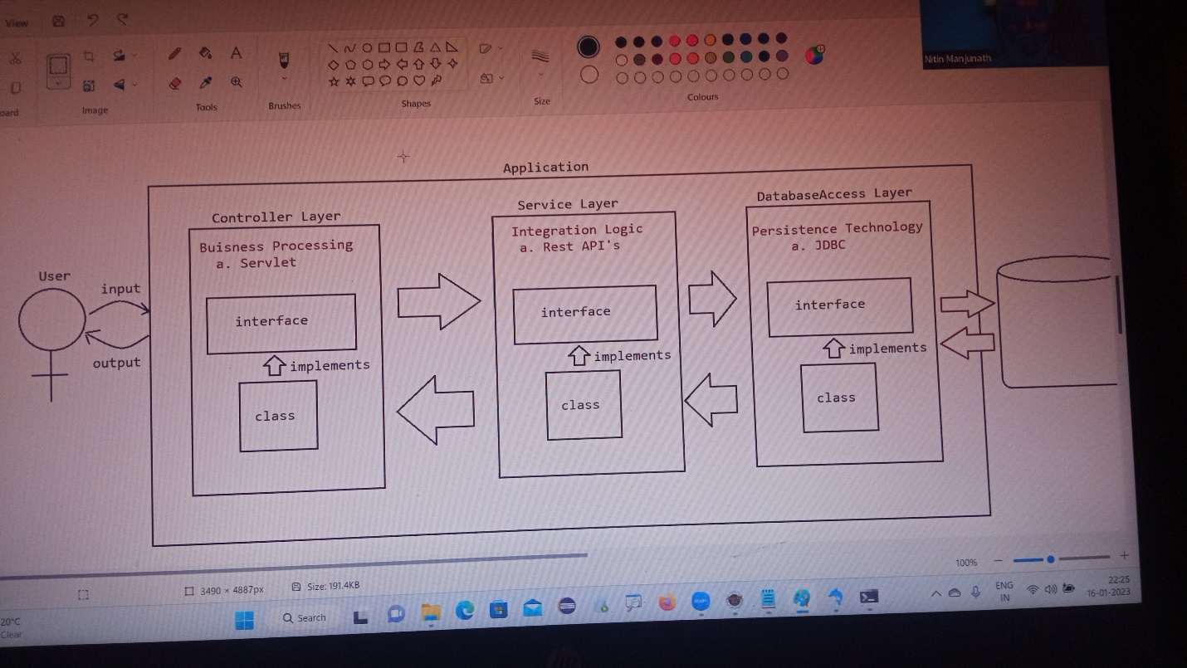

Large Object

* Binary Large Object (BLOB)

Eg: images, audio files, video files….

* Character Large Object (CLOB)

Eg: txt files, .pdf files ,. Xml files

Working with large objects(BLOB and CLOB)

Sometimes as part of programming requirement, we have to insert and retrieve large files like images, video files, audio files, resume etc with respect to database.

Eg: upload image in matrimonial web sites

Upload resume in job related web sites

To store and retrieve large information we should go for large objects(LOBS)

There are 2 types of Large Objects.

1)Binary large object (BLOB)

2)Character large object(clob)

1) Binary Large Object (BLOB)

* A BLOB is a collection of binary data stored as a single entity in the database
* BLOB type objects can be images, video files, audio files etc…
* BLOB datatype can store maximum of “4GB” binary data.

2) CLOB (Character Large Objects):

* A CLOB is a collection of character data stored as a single entity in the database.
* CLOB can be used to store large text documents (may plain text or xml documents
* CLOB type can store maximum of 4GB data.

Eg: resume.txt

Steps to insert BLOB type into database:

1. Create a table in the database which can accept BLOB type data.

Create table persons(personid int, personname varchar(25),image BLOB);

1. Represent image file in the form of java file object.

File f=new File(“image.png”);

1. Create FileInputStream to read binary data represented by image file

FileInputStream fis=new FileInputStream(f);

1. Create preparedstatement with insert query.

PreparedStatement pst=con.prepareStatement(“insert into persons values(?,?,?)”);

1. Set values to positional parameters.

Pst.setInt();

Pst.setString();

Pst.setBinaryStream();

To set values to BLOB datatype, we can use the following method: setBinaryStream()

Public void setBinaryStream (int index, InputStream is)

Public void setBinaryStream (int index, InputStream is, int length)

Public void setBinaryStream (int index, InputStream is, long length)

1. Execute sql query

Pst.executeUpdate();

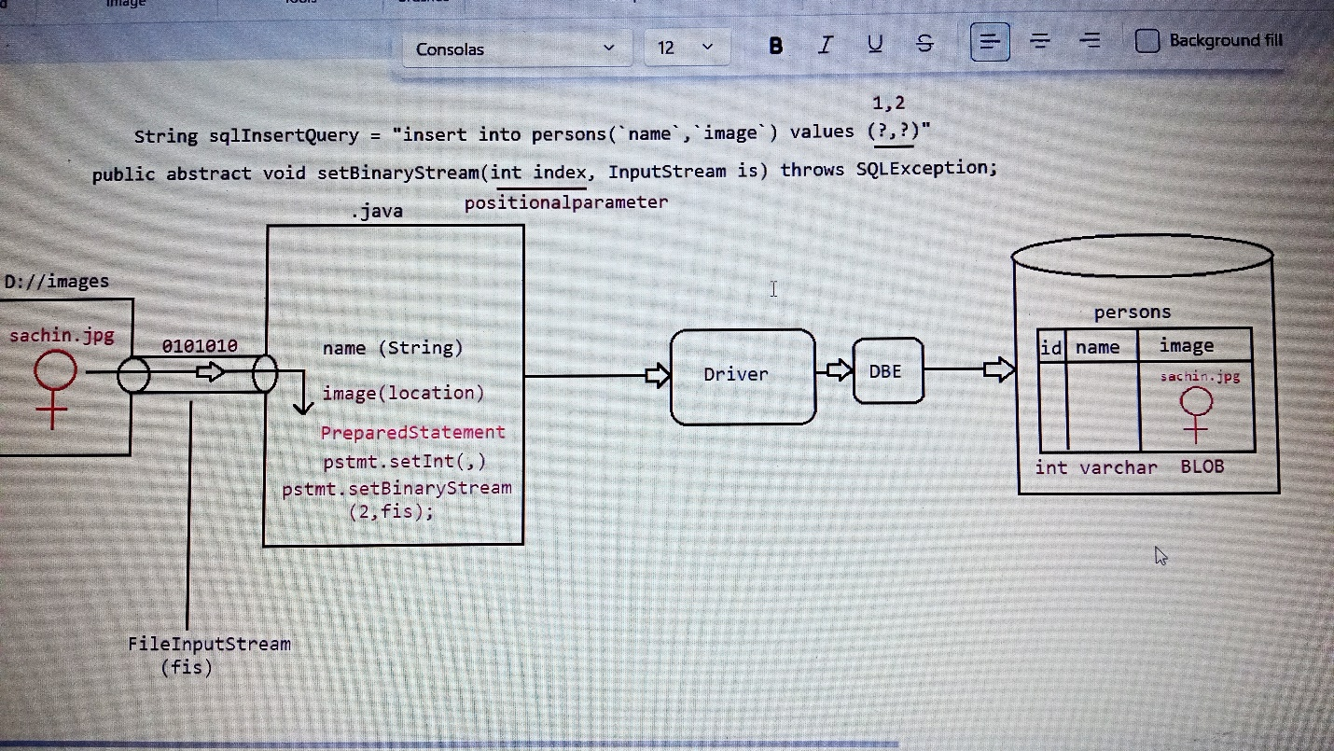

Retrieving BLOB:

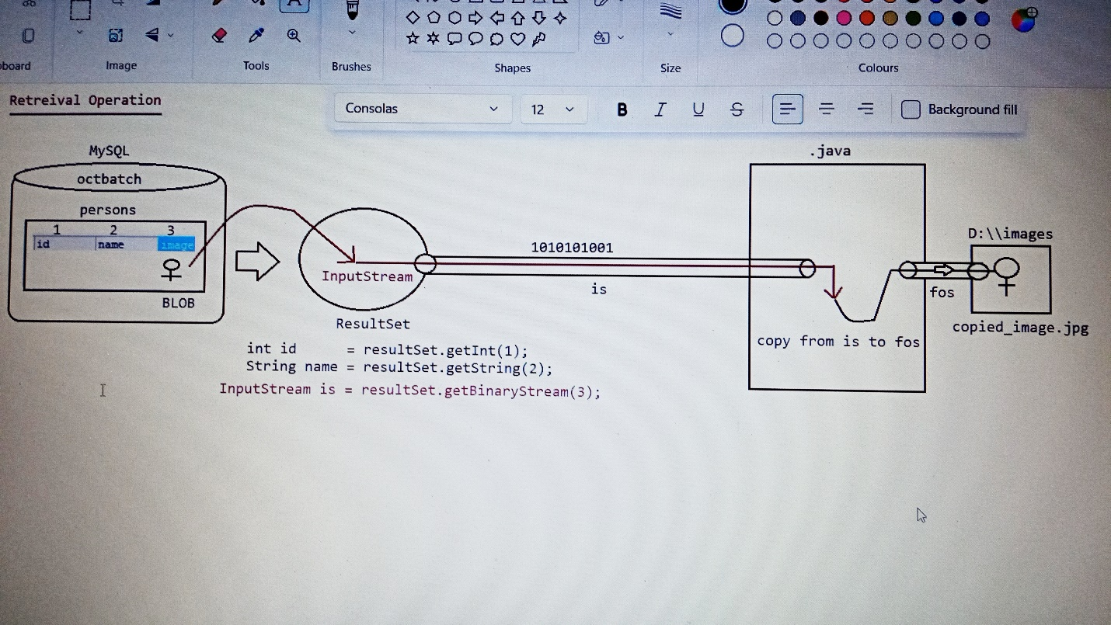

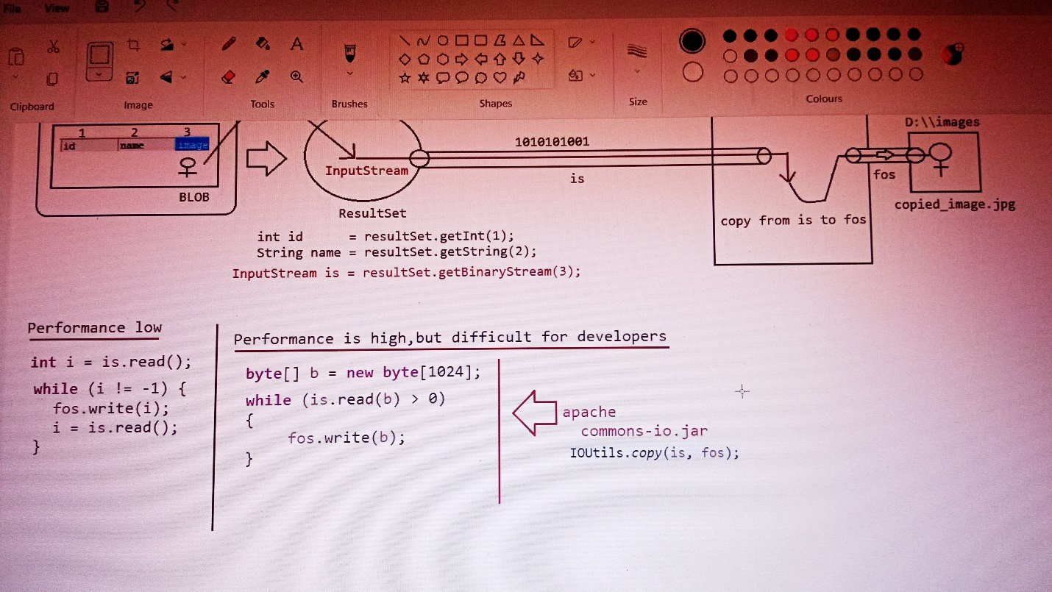

CLOB (character long objects):

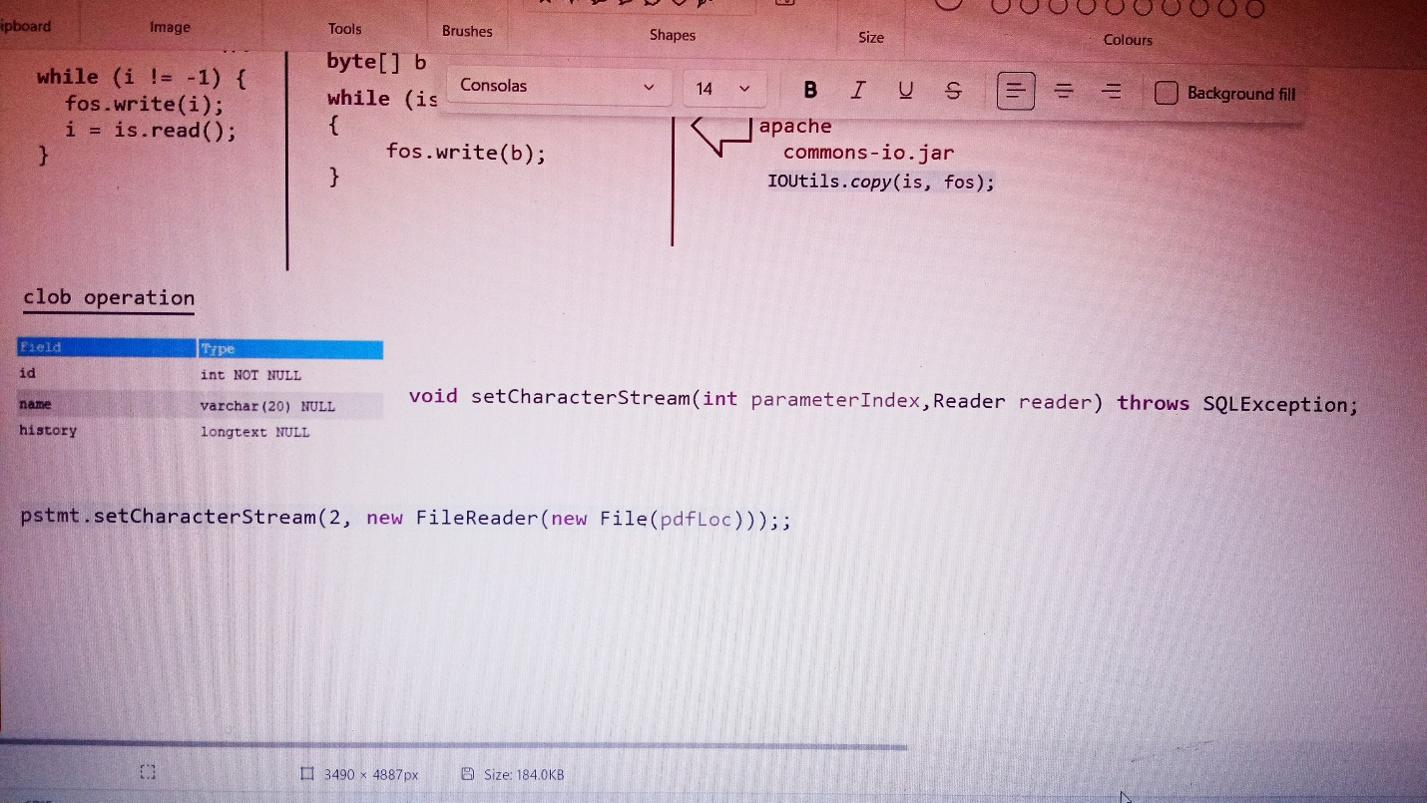

Retrieving the CLOB:

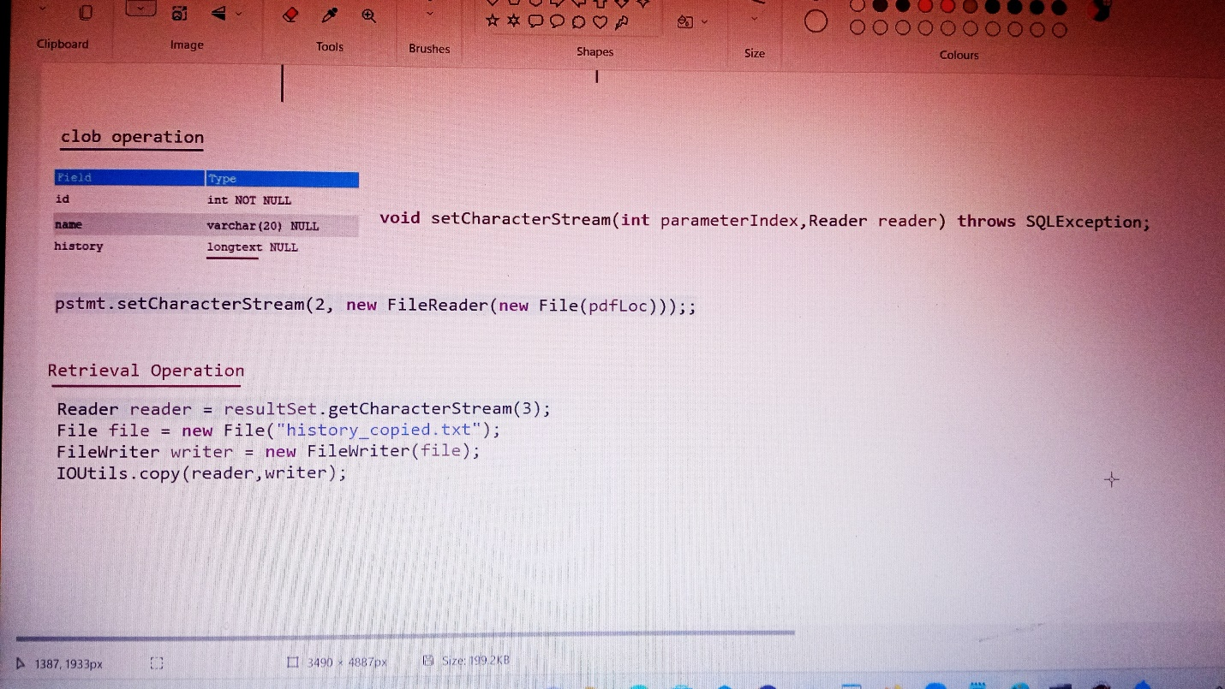

SQL Injection:

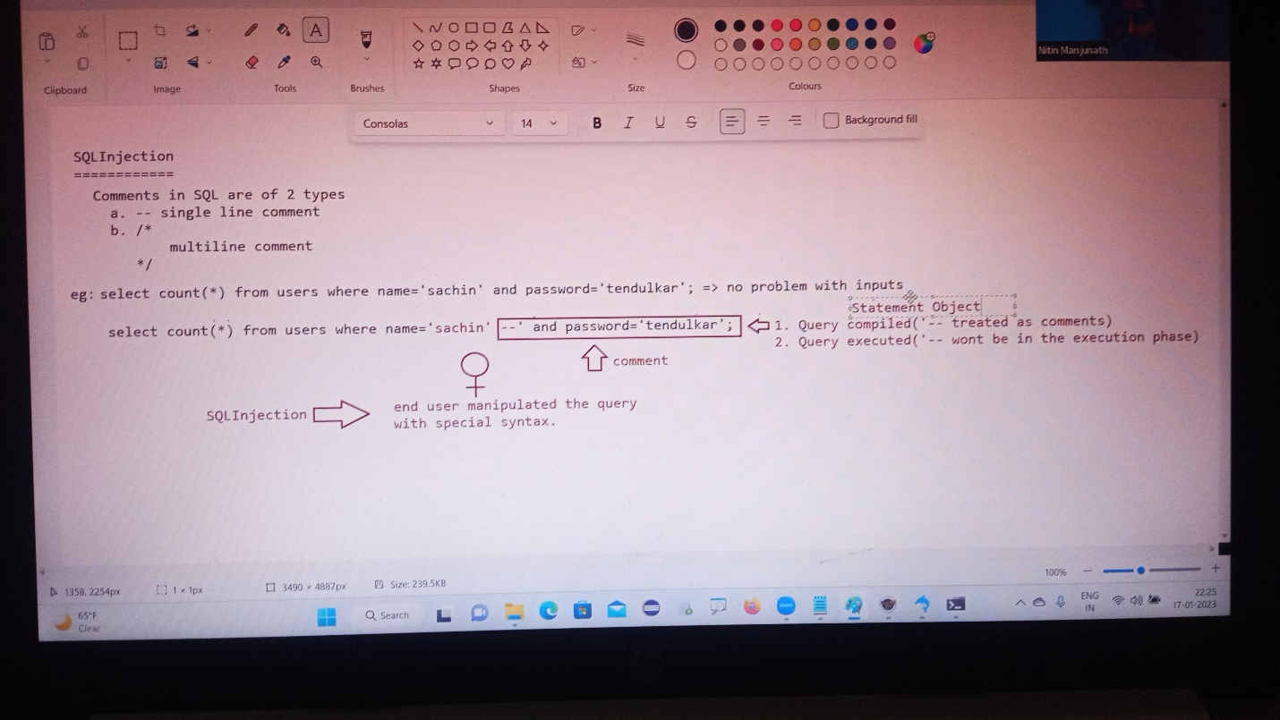

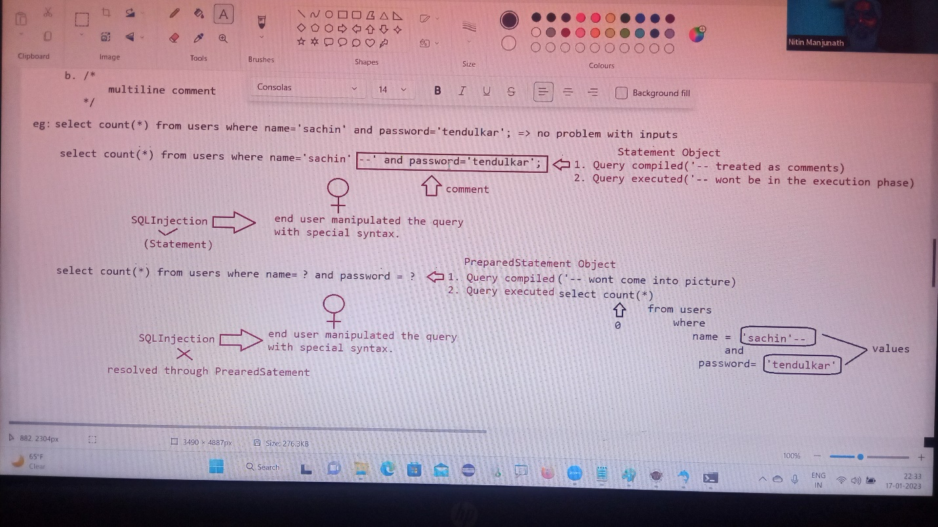

CallableStatement:

Statement(I) =>Executing the query(query should be written by java developer)

Preparedstatement(I) => Executing the query(query should be written by java developer)

CallableStatement(I) => Executing the query (Query will be coded by DBA and present inside database)

If we want to execute only StoredProcedure can we use statement/preparedstatement?

Answer: No, we need to use “callableStatement”

In programming if any code is repeatedly required, we can define the code inside the method and we can call that method multiple times based on our requirement.

Hence the methods are best reusable component in programming.

Similarly in database programming, if any group of sql statements is repeatedly requirement then we define those sql statements in a single group and we call that group repeatedly based on our requirement.

This group of sql statements that perform a particular task is nothing but “stored procedure”.

Stored procedure is the best reusable component at database level.

Stored procedure

It refers to group of SQL statements that perform particular task

These stored procedures are stored permanently in database for future usage and hence the name “stored procedure” usually stored procedure are created by databaseadmin(DBA).

Similar to methods stored procedures has its own parameters

Stored procedures have 3 parameters

1. IN parameters (to provide input values)
2. OUT parameters (to provide output values)
3. INOUT parameters (to provide and to collect output)

Stored procedure example:

USE `images`;

DROP procedure IF EXISTS `get_product_details`;

DELIMITER $$

USE `images`$$

CREATE PROCEDURE `get_product_details` (IN id INT,OUT pname varchar(25),OUT rate int,OUT qnty int)

BEGIN

select productname,price,qty into pname,rate,qnty from product

where productid=id;

END$$

DELIMITER ;This command will be executed by DBA Administrator

To call the stored procedure we use the following syntax as shown below:

call get_product_details(1,@pname,@rate,@qunty);

select @pname,@rate,@qunty;

syntax for calling stored procedure from java program

String storedProcedurecall=”{call product_get_details(?,?,?,?)}”;

callableStatement cstmt=connection.preparecall(storedprocedurecall);

When jvm encounters the above line, jvm will send the call to database

DataBase engine will check whether the specified stored procedure is available or not.

If it is available then it will return callablestatement object representing that procedure.

Note:

Eg: call p_get_product_details_by_id(?,?,?,?)

setXXXX() -> available to take care of setting the input values as per the DBengine datatypes.

Eg: setInt(1,id)--------------------🡪int

setString(2,name--🡪varchar

Before getting the value from the storedprocedure, we need to register the out variables with java specific datatypes.

Registering the output variables of Storedprocedure

1. To map the java datatype and Database specific datatypes we need to use some mechanism.
2. The mechanism used in “JDBC Types” which is also known as “Bridge Types”.

Eg: java datatype -> int

JDBC type -> Types.INTEGER

DB datatyoe -> number

Eg: java datatype -> String

JDBC type -> Types.VARCHAR

DB datatype -> varchar, varchar2

Eg: java datatype -> java.util.Date

JDBC type -> Types.DATE

DB datatype -> Date

getXXXX() -> available to get the value from the DBE as per the DB specific datatype

DB(varchar) ---🡪 JAVA(String)

Note

To execute stored procedure we use execute().

Stored procedure to retrieve all the records based on the product name

DELIMITER $$

CREATE

PROCEDURE ‘octbatch’.’p_GET_PRODUCT_BY_NAME’(IN name1 varchar(@5),IN name2 varchar(20))

BEGIN

SELECT pid,pname,price,qty from products WHERE pname IN(name1,name2);

END$$

DELIMITER;

To call storedprocedure we use the following syntax

CALL ‘P_GET_PRODUCT_BY_NAME’(‘fossil’,’tissot’);

Output:

Pid pname price qty

1 fossil 15000 2

2 tissot 35000 3

One statement object can be used to execute multiple queries

executeUpdate ();

executeQuery ();

Statement

One PreparedStatement Object can be used to execute only one queries with change/no change in inputs.

executeUpdate ();

executeQuery ();

ex

PreparedStatement

One CallableStatement Object can be used to execute to call only stored procedure with change /no change in inpts

execute();

CallableStatement

Explanation:

Statement:

**DataBase**

**Java Application**

N/W

Compile Time

Request Time

Response Time Execution Time

Total time parquery=RT+C.T+E. T+R.T

= 1ms+1ms+1ms+1ms

=4ms

For 1000 queries = 1000*4

= 4000ms

PreparedStatement:

**DataBase**

**Java Application**

N/W

Request Time

Execution Time

Response Time

Total time parquery=RT+E. T+R.T

= 1ms+1ms+1ms

=3ms

For 1000 queries = 1000*3

= 3000ms

In the above 2 cases, we are trying to submit 1000 queries to the database one by one

For 1000 queries to be submitted we need to hit the database 1000 times.

It increases the network traffic between java application and database.

It creates performance problems also.

To overcome the above problem, we should go for Batchupdates.

Grouping all the related queries into single batch and we can send that batch at a time to the database.

DataBase

Query-1

Query-2

Query-3

Query-4

Query-5

Query-6

Query-7

Qq

N/W

Java Application

Batch Of Queries

With statement batch update Advantage

Per 1000queries=R.T+1000C.T+1000*E.T+Resp.T a. reduce network traffic.

=1ms+1000*1ms+1000*1ms+1ms b. improve performance

=1ms+1000ms+1000ms+1ms

=2002ms

With preparedstatement batch update

Per 1000queries=R.T+1000*E. T+Resp.T

=1ms+1000*ms+1ms

=1ms+1000ms+1ms

=1002ms

Transaction Management:

Process of combining all the related operations into a single unit and executing on the rule “either all or none” is referred as “Transaction Management”.

Case1: Fund transfer

1. Debits funds from sender account
2. Credits funds into receiver account

All operations should be performed as single unit

If money from sender account is debited, and if the money doesn’t reach to receiver’s account, then there may be a change of “Data inconsistency problem”

Case2: Movie Ticket Reservation

1. Verify the status
2. Reserve the ticket
3. Payment
4. Issue ticket

All operations should be performed as single unit.

If some operations success and some operations fails then there may be “Data inconsistency problem”.

Transaction Properties:

Every transaction should follow the following four ACID properties

1. A -> Atomicity

Either all operations should be done or none.

1. C -> Consistency

It should ensure bringing the database from one state to another state.

1. I -> Isolation

It ensures the transactions are isolated from other transactions.

1. D -> Durability

It means once the transaction is committed, the results are permanent even in the case of system restart, errors, etc.….

What are the types of transactions are available?

1. Local Transaction
2. Global Transaction
3. Local Transaction

All operation in transaction are executed over the same database.

E.g.: Funds transfer from one account to another account where the both the account in the same bank.

1. Global Transaction

All operations in transaction are executed over the different database

E.g. Funds transfer from one account to another account where the accounts are related to different banks.

Note:

JDBC supports only local transactions.

If we want global transactions then we need to go for frameworks like spring/hibernate or EJB’s.

Since autocommit(false) is available then, the query result will not be reflected in the database.

To reflect the result in the database we need to use

1. Commit ()
2. Rollback ()

By doing so we are following ACID Properties.

**D**

**B**

**E**

connection

Database

query

**query**

.java

#1

Connection.setAutoCommit(false)

Query1

#3 and #4 based on condition

;;;;;;;;;;

Query2

;;;;;;;;;;;;

If(……)

Connection.commit(); Else Connection.rollback();

Process of transaction management:

1. Disable the autocommit nature of JDBC

Connect.setAutoCommit(false);

1. If all operations are completed means then we can commit the transaction using the following method connection.commit();
2. If any sql query fails, then we need to rollback the operations which are already completed using the following method

connection.rollback();

SavePoint (I)

Within a transaction, if we want to rollback a particular group of operations based on some condition then we need to use savepoint.

1. Getting savepoint using the following method

Savepoint sp=connection.setSavePoint();

1. To perform rollback operation for a particular group of operations w.r.t savepoint then we need to use rollback.

connection.rollback(sp);

1. We can release the savepoint or delete the savepoint as shown below

connection.releaseSavePoint(sp);

Case study

Connection.setAutocommit(false);

Operation1

Operation2

Operation3

SavePoint sp=connection.setSavePoint();

Operation4

Operation5

If(balance<1000)

Connection.rollback(sp);

Else

Connection.releaseSavepoint(sp);

Connection.commit();

If balance<1000 then operation 4,5 will be rollbacked, otherwise all the operations will be commited.

E.g. connection.setAutocommit(false);

St.executeUpdate(“insert into hero values(‘Hero’,‘victoryvenkatesh’)”);

St.executeUpdate(“insert into hero values(‘Hero’,‘NTR’)”);

SavePoint s=connection.setSavePoint();

St.executeUpdate(“insert into hero values(‘villan’,‘jfdifkdj’)”);

Connection.rollbac(sp);

;;;;;;;

Connection.releaseSavePoint(sp);

;;;;;;;

Connection.commit();

ResultSet

Types of Resultset

Division – 1 (Based on the type of operation performed on ResultSet)

1. Read only Resultset(static Resultset)
2. Updatable Resultset(dynamic Resultset)

Division -2 (Based on the movement of cursors)

1. Forward only Resultset (Non – Scrollable)
2. Scrollable Resultset

* Scroll Insensitive Resultset
* Scroll Sensitive Resultset

absolute () -> It works from the BFR or from ALR.

Relative () -> It works w.r.t current position

In both the methods positive means move in forward direction, negative means move in backward direction.

Note:

rs.last and rs.absolute(-1) both are equal

rs.first() and rs.absolute(1) both are equal

scroll InSensitive ResultSet

After getting resultSet if we are performing any operations in the database, and if those changes are not reflecting to the resultset, such type of Resultset are called as “scroll Insensitive Resultset”.

Public static final int TYPE_SCROLL_INSENSITIVE

Scroll Sensitive Resultset

After getting resultSet if we are performing any operations in the database, and if those changes are reflecting to the resultset, such type of resultset are called as “Scroll Sensitive ResultSet”.

Public static final int TYPE_SCROLL_SENSITIVE

Note:

When we make the Resultset as ScrollSensitive, then we need to use resultset.refreshRow() to get the updated records from the database.

Updatable Resultset

It is possible to perform delete operation using resultset without writing delete query

resultset.deleteRow() -> This method would delete the record based on the cursor position of resultset.

It is possible to perform insert operation using resultset without writing insert query.

1. resultSet.moveToInsertRow();//creates a empty record in a buffer
2. resutSet.updateXXXX(int pos, Object value);//insert the values based on the column data.
3. resultSet.insertRow();//record will be inserted to the table with the updated values.

It is essentially a buffer where a new row may be constructed by calling the updater methods prior to inserting the row into the resultset.

Only the updater, getter, and insertrow methods may be called when the cursor is on the insert row

All of the columns in a result set must be given a value each time this method is called before calling insert row.

An updater method must be called before a getter method can be called on a column value.

It is possible to perform update operation using resultset without writing update query

1. resultSet.getXXX(int pos)//getting old value from resultset
2. resultset.updateXXXX(int pos,Object newvalue);//update the new value
3. resultset.updateRow();//record will be updated to the table as per the record status.

Working with Excel Sheet

To work with Excel Sheet, we need to use HXTT company supplied driver we need to use.

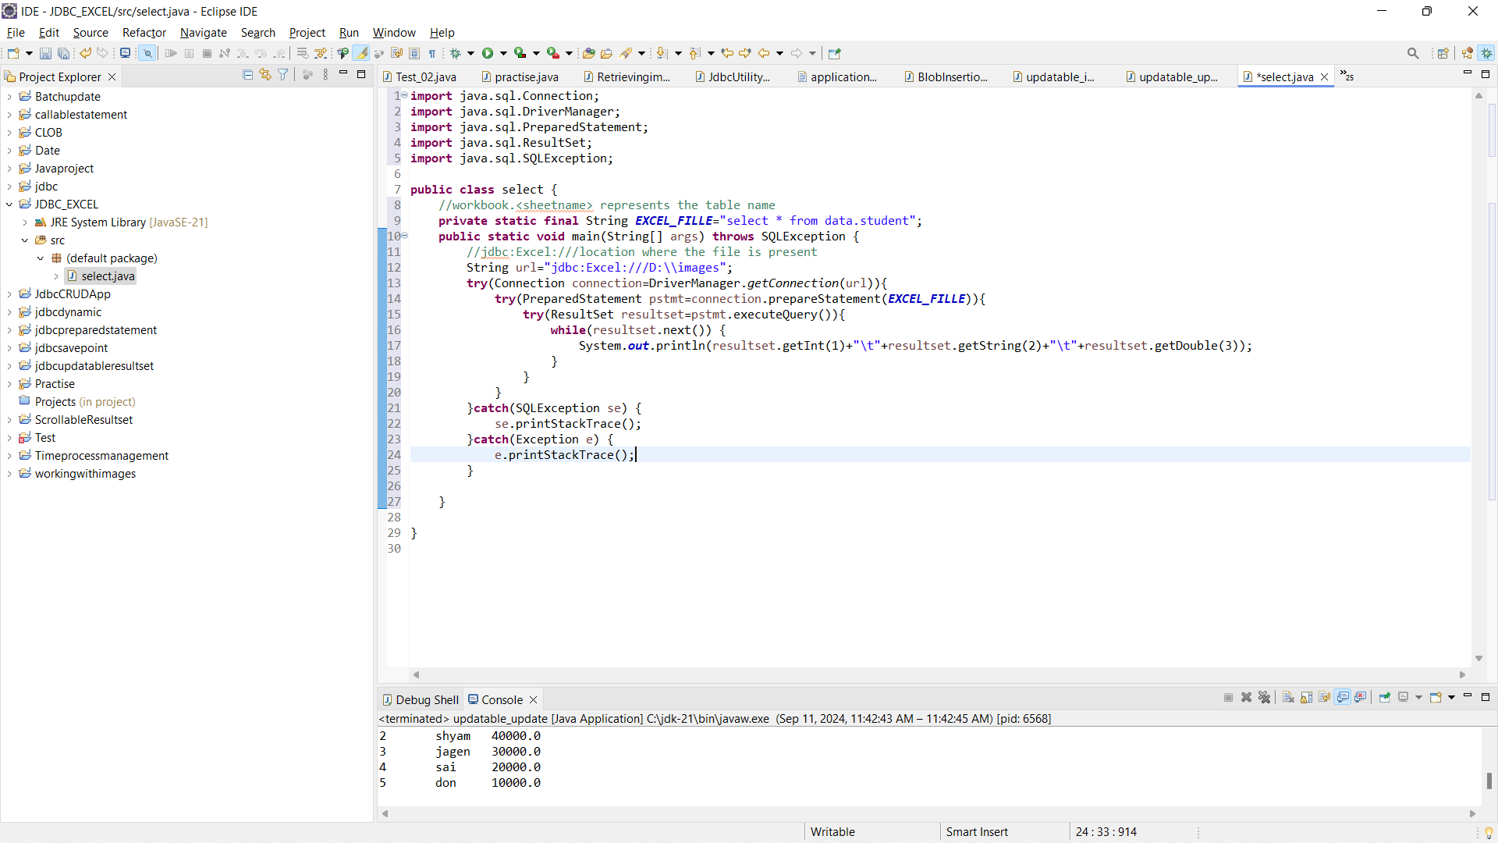

pooling:

Physical connection

.java

**This approach is wrong because of following reasons**

**Performance is low**

1. **Creating connection object when user sends request takes time.**
2. **After using connection object, destroy the connection object takes time.**

request

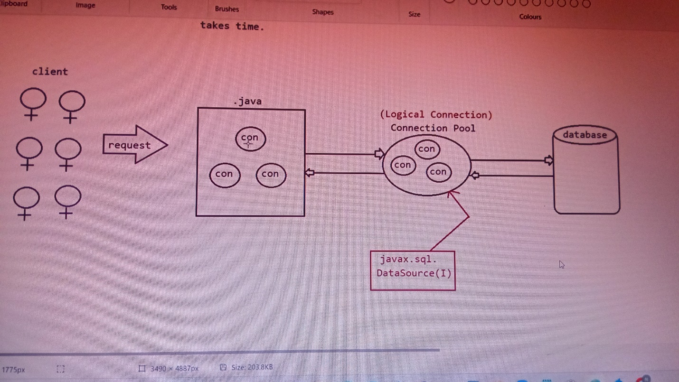

**Advantages:**

1. **We need not want to make clients wait to get the connection object, if connection object is available pick from connection pool and give the connection object for service.**
2. **After using the connection object, connection object will be returned back to connection pool so it supports reusability.**

Note:

The no of objects created in the connection pool depends on the dbvendor and since the count of objects is less (10), it is not suitable for production environment.

DBVendors also supplied “connection pooling” mechanism in the jars.

The best suited vendor who supplies connection pooling mechanism is “hikaricp”.

For MYSQL database to implement connection pooling we need to use the class called “com.mysql.cj.jdbc.MysqlConnectionPoolDataSource”.

Hikaricp

HikariCP is a "zero-overhead" production ready JDBC connection pool.

It is the 3rd party supplied jar which helps us to improve connection pooling approach.

To use hikaricp in our applications we need to use 2 jars

1. hikaricp jar
2. sl4j jar

properties file:

jdbcUrl=jdbc:mysql://localhost:3306/Employee

dataSource.user=root

dataSource.password=Venkyvenkatesh8@

**package** Hikariccode;

**import** java.sql.Connection;

**import** java.sql.ResultSet;

**import** java.sql.SQLException;

**import** java.sql.Statement;

**import** com.zaxxer.hikari.HikariConfig;

**import** com.zaxxer.hikari.HikariDataSource;

**public** **class** Test_01APP {

**public** **static** **void** main(String[] args) **throws** SQLException {

String configfile="E:\\IDE\\Hikariconnectionpooling\\src\\db.properties";

HikariConfig config = **new** HikariConfig(configfile);

**try**(HikariDataSource Datasource=**new** HikariDataSource(config)){

Connection connection=Datasource.getConnection();

Statement statement=connection.createStatement();

ResultSet resultset=statement.executeQuery("select empid,name,salary from emp");

System.***out***.println("empid\tname\tsalary");

**while**(resultset.next()) {

System.***out***.println(resultset.getInt(1)+"\t"+resultset.getString(2)+"\t"+resultset.getInt(3));

}

}

}

}

Output:

[main] INFO com.zaxxer.hikari.HikariDataSource - HikariPool-1 - Starting...

[main] INFO com.zaxxer.hikari.HikariDataSource - HikariPool-1 - Start completed.

empid name salary

1 venkatesh 4000

2 shyam 40000

3 jagen 30000

4 sai 20000

5 don 10000

[main] INFO com.zaxxer.hikari.HikariDataSource - HikariPool-1 - Shutdown initiated...

[main] INFO com.zaxxer.hikari.HikariDataSource - HikariPool-1 - Shutdown completed.

Note:

Since hikaricp datasource is best for connection pooling. In springboot by default hikaricp connection pooling is available.

Javax.sql.RowSet:

It is an alternative to ResultSet.

We can use RowSet to handle group of records in more effective way than ResultSet.

RowSet is a child interface of ResultSet.

By default RowSet is Scrollable and updatable.

By default RowSet objects implements Serializable, so RowSet object can be sent over the network.

Resultset Object is default connected object, where as if use rowset we can work in both the modes like connected/DisConnected mode.

There are 2 types of RowSet

1. Connected RowSet.
2. DisConnected RowSet.

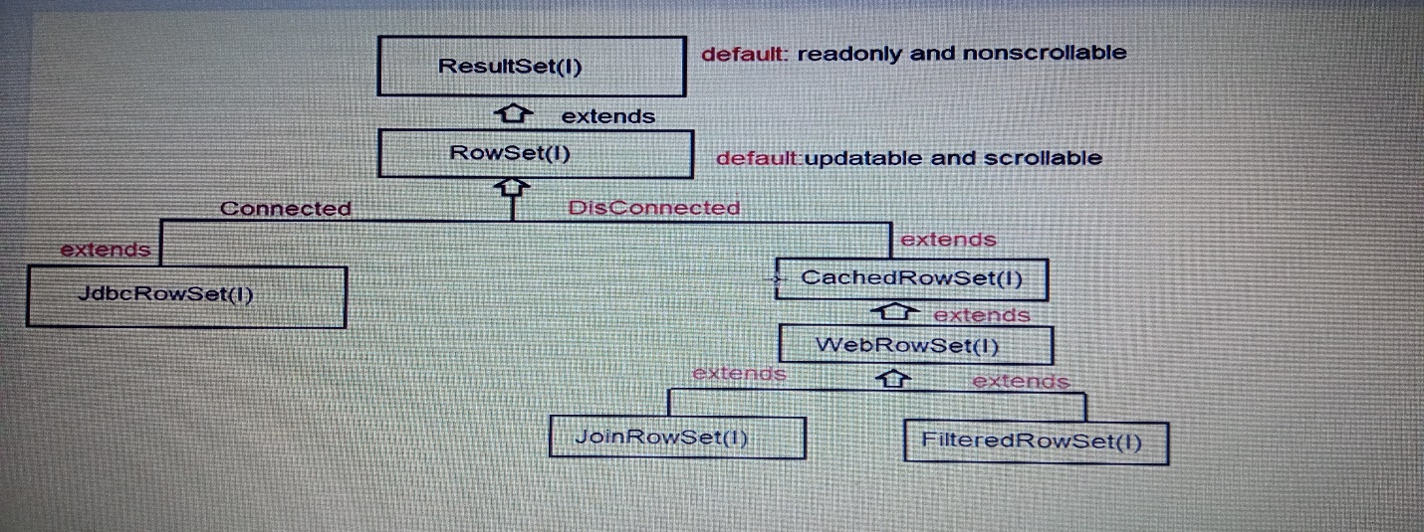

**Not preferred in realtime because driver support from db vendor is not available**

**So in real time we prefer using “RESULTSET”**

Note:

Implementation for RowSet is provided by java vendor only, not by db vendor.

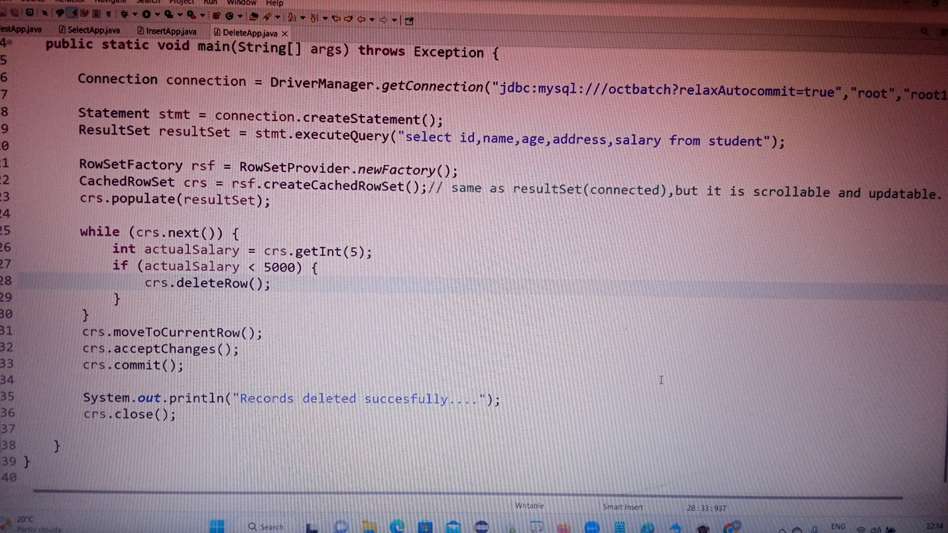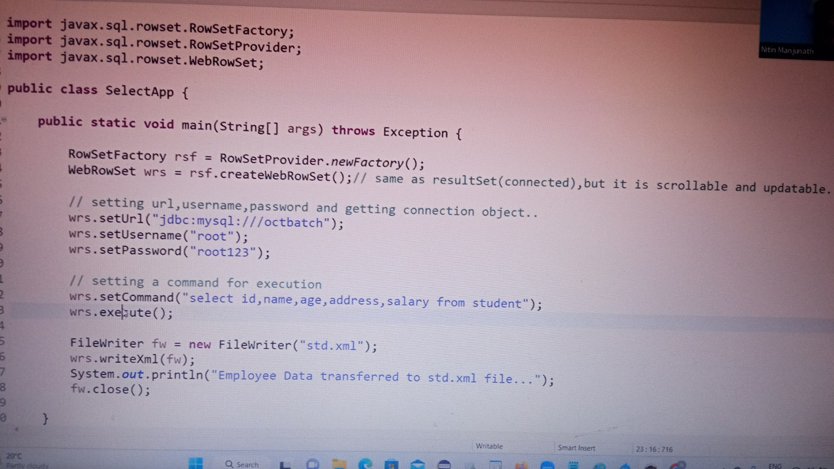

----------------------- JDBC COMPLETED -----------------------------------------